A Mini Project Report *on*

**BLOG USING PHP AND MYSQL**

*by*

Heramb Kulkarni (Roll No. 51)

Shreyas Sarode (Roll No.)

Himanshu Mishra (Roll No.61)

Pranay Gaikwad(Roll No.43)

*Under the guidance of*

Ms. Sonali Sonavane



Department of Information Technology

**GH. Raisoni Institute of Engineering & Technology**

# Pune

**SAVITRIBAI PHULE PUNE UNIVERSITY**

**2020-2021**

Department of Information Technology

G. H. Raisoni Institute of Engineering & Technology

|  |  |  |
| --- | --- | --- |
| |  |  | | --- | --- | | Department of Information Technology  GH. Raisoni Institute of Engineering & Technology | Description: C:\Users\dell\Desktop\Digital Image\download.png |   Date:  **CERTIFICATE**  This is to certify that,  Heramb kulkarni (Exam Seat No.)  Pranay Gaikwad (Exam Seat No.)  Himanshu Mishar(exam Seat No )  Shreyas Sarode(exam Seat No )  of class T.E IT; have successfully completed their mini project work on “ONLINE VOTING SYSTEM’’ at GH. Raisoni Institute of Engineering & Technology in the partial fulfillment of the Graduate Degree course in T.E at the department of **Information Technology**, in the academic Year 2020-2021 Semester – I as prescribed by the Savitribai Phule Pune University.  Ms. Sonali Sonavane Dr. Nilesh Deotale  Guide Head of the Department  (Department of Information Technology) |

# Acknowledgements

With deep sense of gratitude we would like to thanks all the people who have lit our path their kind guidance. We are very grateful to these intellectuals who did their best to help during our project work.

It is our proud privilege to express deep sense of gratitude to, Prof, Principal of G.H.Raisoni institute of engineering and technology pune, for his comments and kind permission to complete this project. We remain indebted to Prof Dr.deotale HOD-CS/IT Department for his timely suggestion and valuable guidance.

The special gratitude goes to Ms. Sonali Sonavane (Project guide) for their expensive, excellent and precious guidance in compilation of this work. We thank all the colleagues for their appreciable help for our working project.

And last we thank all friends and the people who are directly or indirectly related to our project work.

Heramb kulkarni (Exam Seat No.)

Shreyash Sarode (Exam Seat No.)

Himanshu Mishra (Exam Seat No.)

Pranay Gieakwad (Exam Seat No.)

i

|  |  |  |
| --- | --- | --- |
|  | **Contents** |  |
| **Sr. No.** | **Topic** | **Page No.** |
|  | **Acknowledgement** | i |
|  | **Contents** | ii |
|  | **List of Tables** | iii |
|  | **List of Figures** | iv |
|  | **Abstract** | vi |
| **Chapter-1** | **Introduction** | 1 |
|  | 1.1 Overview & Motivation | 1 |
|  | 1.2 Problem Statement | 2 |
| **Chapter-2** | **Scope & Limitation of Project** | 3 |
| **Chapter-3** | **Software Requirement Specification** | 5 |
|  | 4.1 Hardware Requirements | 5 |
|  | 4.2 Software Requirements | 5 |
| **Chapter-4** | **UML Diagarm** | 6 |
|  | 3.1 Usecase Diagram | 7 |
|  | 3.2 Activity Diagram | 8 |
|  | 3.3 Class Diagram | 9 |
|  | 3.4 Swimlane Diagram | 10 |
| **Chapter-5** | **Entity-Relationship Diagram** | 11 |
| **Chapter-6** | **ER to Table Conversion** | 13 |
| **Chapter-7** | **Normalization upto 3NF** | 16 |
| **Chapter-8** | **Schema Diagram** | 18 |
| **Chapter-9** | **Coding(Connectivity)** | 19 |
| **Chapter-10** | **Screen Shots** | 21 |
| **Chapter-11** | **Future Scope** | 24 |
| **Chapter-12** | **Conclusion** | 25 |
| **Chapter-13** | **References** | 26 |

i

**List of Tables**

|  |  |  |
| --- | --- | --- |
| **Table No.** | **Title** | **Page No.** |
| **3.a** | **Software requirement for project** | **3** |
| **3.b** | **Hardware requirement for project** | **3** |
| **6.a** | **voter table of Er to table conversion.** | **12** |
| **6.b** | **login table for voter login** | **36** |
| **6.c** | **Admin** | **39** |
| **7.a** | **1NF** | **11** |
| **7.b** | **2NF** | **11** |
| **7.c** | **3NF** | **12** |

**List of Figures**

|  |  |  |
| --- | --- | --- |
| **Figure No.** | **Title** | **Page No.** |
| 4.1 | Usecase diagram | 10 |
| 4.2.1 | Activity diagram (admin side) | 11 |
| 4.2.2 | Activity diagram (user side) | 13 |
| 4.3 | Class diagram | 16 |
| 4.4  5.0  8.0 | Swimlane diagram  ER diagram  Schema diagram | 36  57  57 |

# Abstract

# The purpose of online blogging system to automate the existing manual system by help of computerize equipment and full-fledged computer software, fulfilling there requirements, so that their valuable data/ info can be stored for a longer period with easy access and manipulation of the same. The required software and hardware are easily available to easy the work with.

# Online blogging system, as described above, can lead to error free, secure, reliable and fast management system. It can assist the user to concentrate on their other activities rather to concentrate on the record keeping. Thus it will help collage in better utilization of resources. The collage can maintain computerized records without redundant entries/. That means that one need not be distracted by information that is not relevant,, while being able to reach the information

# The aim is to automate its existing manual system by help of computerized equipment and full-fledge computer software, fulfilling their requirements. Basically the project describes how to manage for performance and good service to its users.

**Chapter 1**

**Introduction**

A blog is a type of website, usually maintained by an individual with regular entries of commentary, descriptions of events, interaction, or other material such as graphics or video. Entries are commonly displayed in reverse-chronological order. Educators are using blogs in many ways including as online portfolios, for teachers and students for provision of course content, as a record of field notes, as discipline specific spaces for knowledge sharing, as a space for student dialogue and for class administration.

# The aim is to automate its existing manual system by help of computerized equipment and full-fledge computer software, fulfilling their requirements. Basically the project describes how to manage for performance and good service to its users.

# So we are developing blogging site for collage, so that it helps you connect and build relationships with leads and students. Our blog is a great place to provide content that adds value for readers and helps them better understand how to solve their greatest challenges. You can stay connected and get information ablaut different events scheduled in collage, also user can get detailed info about the collage like collage campus, hostel, fees structure, different courses you can register on.

**Chapter 2**

**Scope & limitation of project**

**Scope of the project:**

This project will help perfect collection and management of data. In very short time, the collection will be obvious, simple and sensible.

* Our project aims at Collage Business process automation. i.e. we have tried to computerized various manual process to online blogging system processes.
* In our system person can write his own blogs, make copies of them and blogs can be published very easily.
* In our project, it is not necessary to create the manifest but we can directly print it, which saves our time.
* To assist the staff in capturing the effort spent on their respective working areas.
* To utilize resources in an efficient manner by increasing their productivity through automation.
* Have a good user interface.
* Be expandable.
* Be easy to understand by user and operator.
* Provide filter reports on Topics, Entries, Views
* You can also save and export copy of blog

**Limitation of the project:**

* Mainly this blog is only on web so the responsiveness of blog can be bad on 4inch or lower screen aspect ratio devices.
* The blog works perfectly fine on computer and mobile but there would be some glitches if the mobile android version is less than 4.4.
* The blog is an expandable project so at the initial stage not much features are added.

**Chapter 3**

**Software Requirement Specification**

**3. a. Hardware requirement:**

|  |  |
| --- | --- |
| **Hardware Requirement** | **Specification** |
| RAM | Minimum 512 MB of RAM |
| HDD | Minimum 10GB HD |
| Processor | Pentium PIV Processor and above |

**3. b. Software requirement:**

|  |  |
| --- | --- |
| **Software requirement** | **Specification** |
| Operating System | Windows/ Linux |
| Database | MySQL |
| Server | Xampp 1.8.2 |

**Chapter 4**

**UML Diagram**

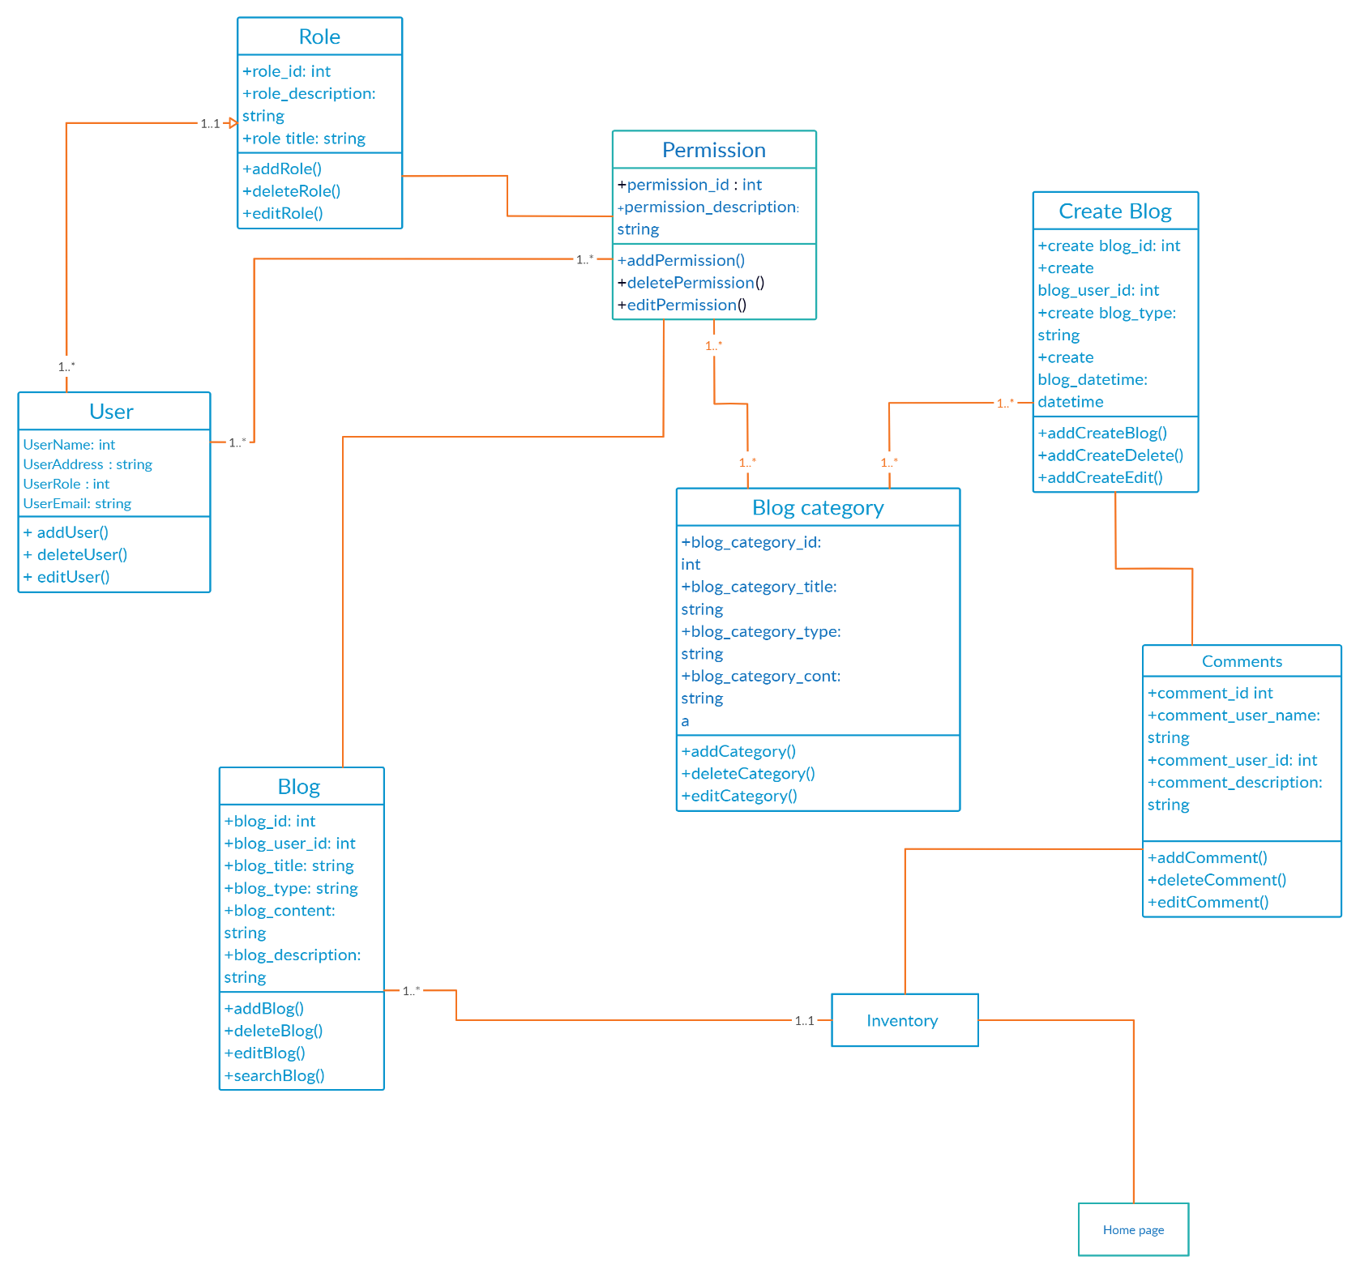**4.1 Class Diagram:**

**4.2 Use case Diagram:**

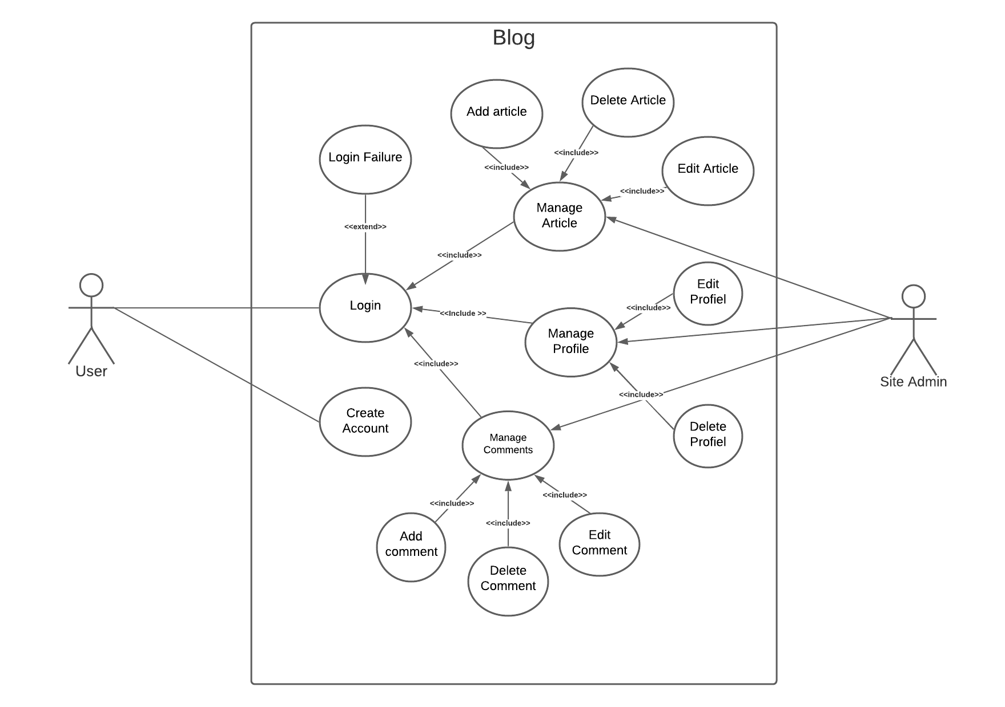

**4.3 Activity Diagram:**

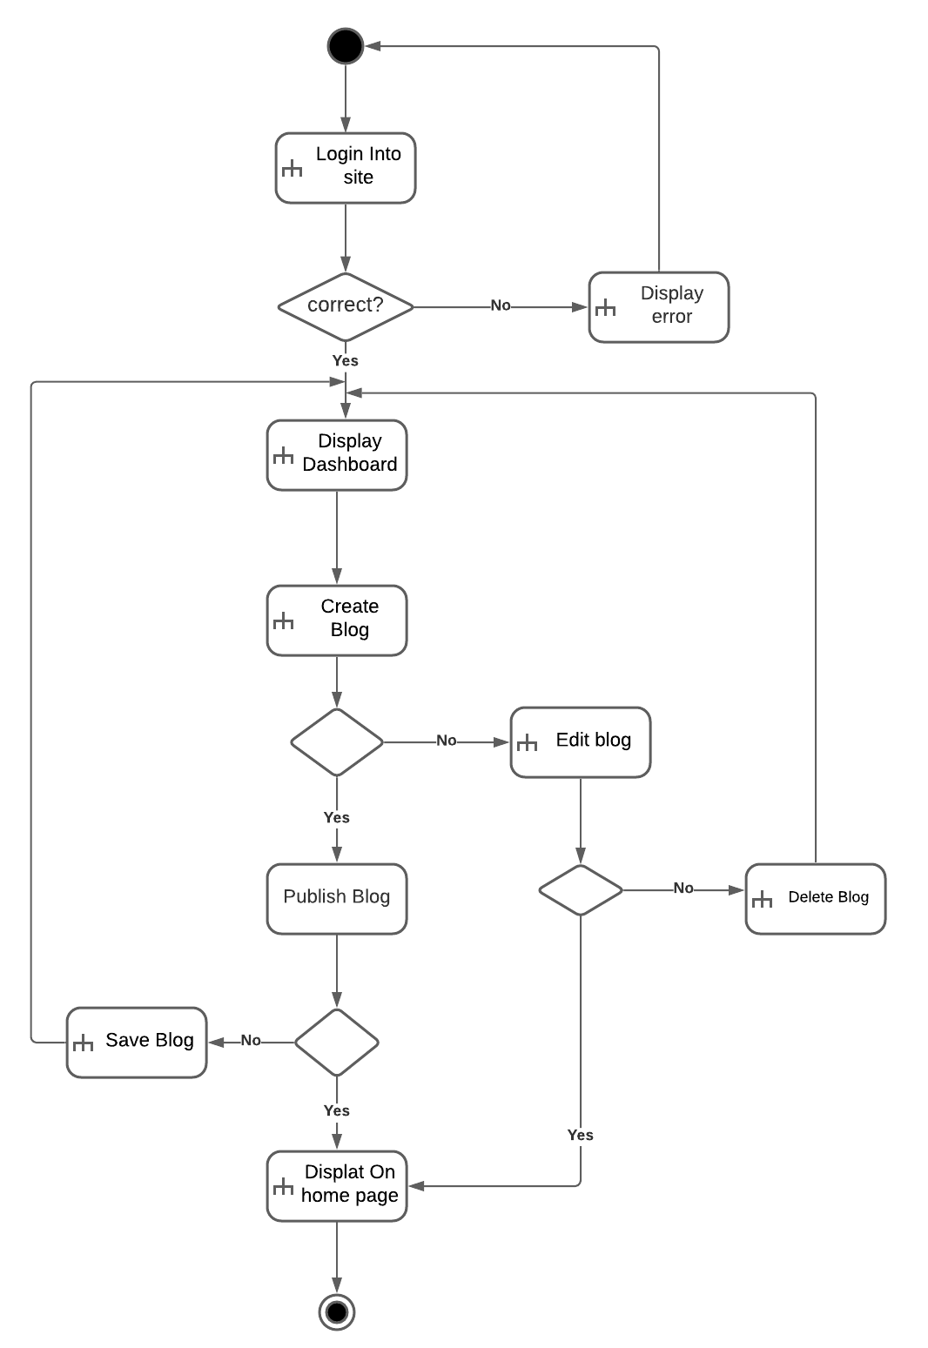

**4.4 Swimlane Diagram:**

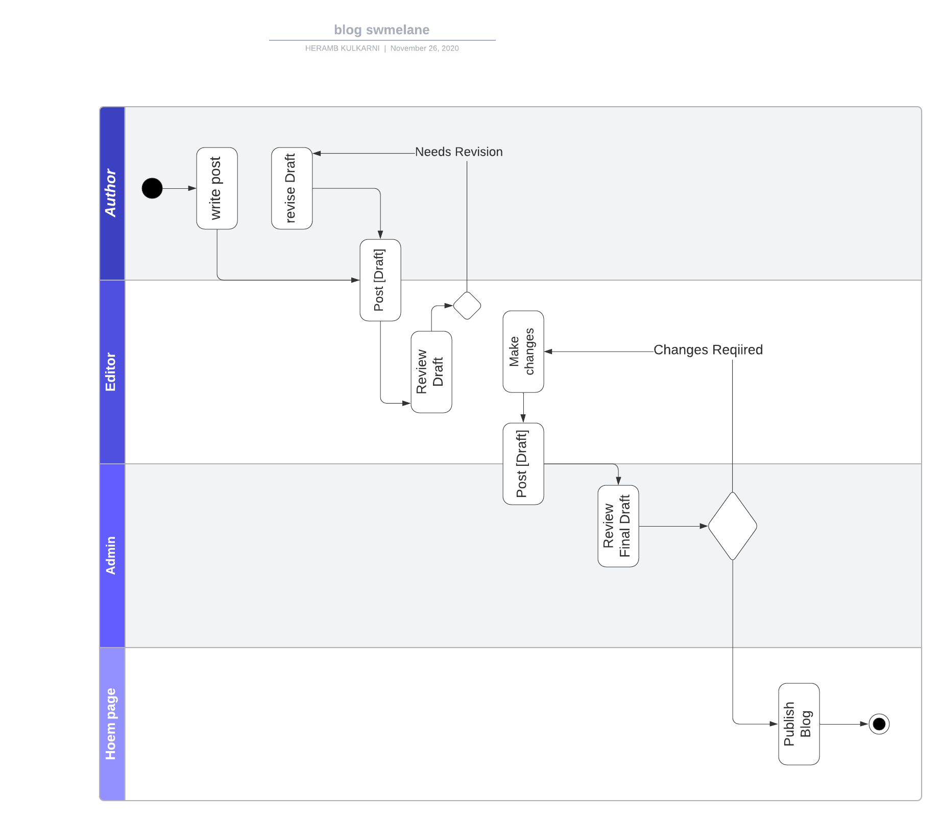

**Chapter 5**

**Entity-Relationship Diagram**

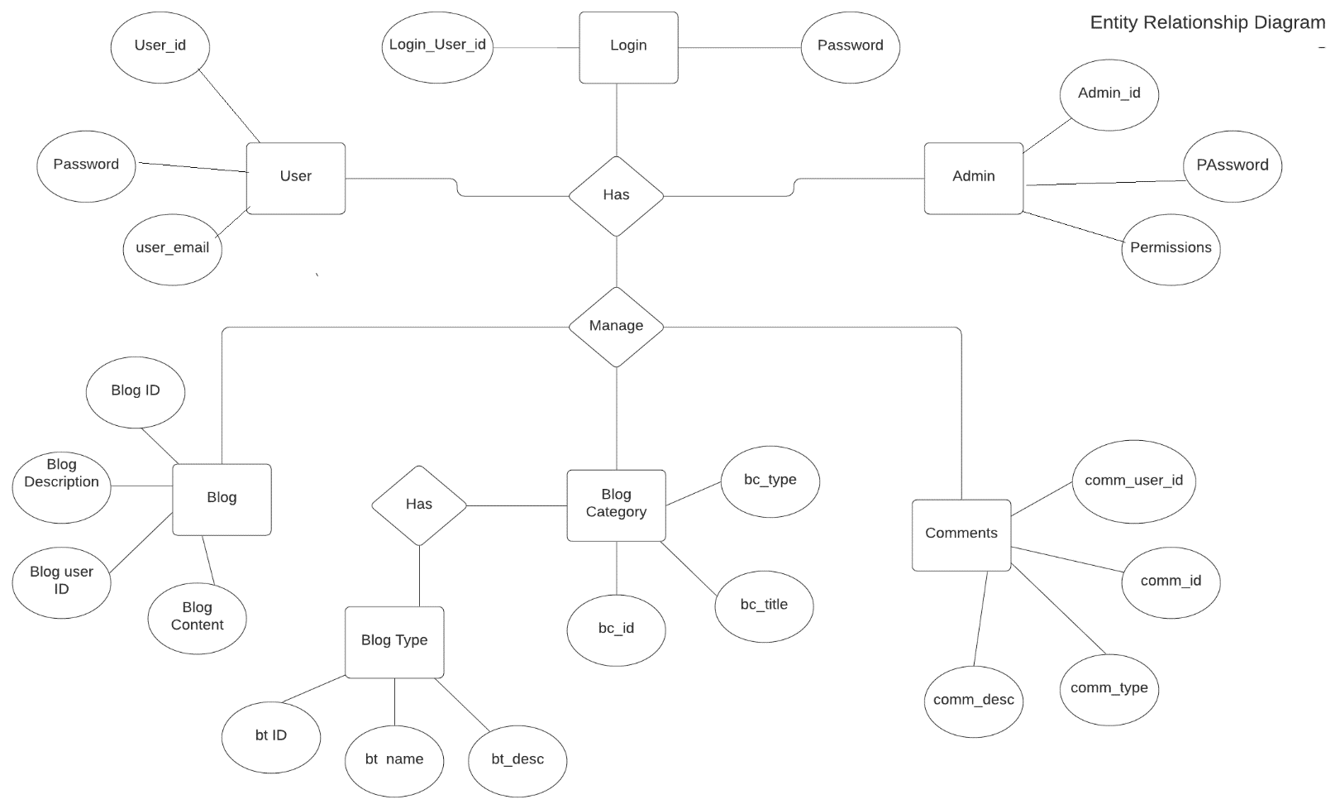

**Chapter 6**

**ER to table conversion**

**6.a Blog table**

|  |  |  |
| --- | --- | --- |
| **Field name** | **Data type** | **Description** |
| blog_id | Integer | Unique id for blog (Primary key) |
| Blog title | Varchar | Title of the blog |
| Type | varchar | gender of voter |
| Date | Integer | year of voter |

**6.b Login table**

|  |  |  |
| --- | --- | --- |
| **Field name** | **Data type** | **Description** |
| Email | Varchar | Email of the user |
| Password | Varchar | password for login |

**6.c Admin Table**

|  |  |  |
| --- | --- | --- |
| **Field name** | **Data type** | **Description** |
| User name | varchar | Name of user |
| User position | varchar | Position of user. (Author/ Admin) |
| User blogs | Integer | Number of blogs uploaded by user |
| Post | varchar | Number of posts |

**Chapter 7**

**Normalization up to 3NF**

**7. a. 1NF**

|  |  |  |  |  |  |  |
| --- | --- | --- | --- | --- | --- | --- |
| **Blog id** | **User id** | **password** | **first name** | **last name** | **No of blogs** | **Position** |
| 1 | 123123 | xYvwZ | Zara | Larsson | 4 | Author |
| 2 | 142743 | yKwuB | Taylor | Swift | 2 | Admin |

**7. b. 2NF**

|  |  |  |  |
| --- | --- | --- | --- |
| **Blog id** | **User id** | **first name** | **last name** |
| 1 | 123123 | Zara | Larsson |
| 2 | 142743 | Taylor | Swift |

|  |  |  |
| --- | --- | --- |
| **Blog id** | **User id** | **No of blogs** |
| 1 | 123123 | 4 |
| 2 | 142743 | 2 |

|  |  |  |
| --- | --- | --- |
| **Blog id** | **User id** | **Position** |
| 1 | 123123 | Author |
| 2 | 14743 | Admin |

**7. c. 3NF**

|  |  |  |
| --- | --- | --- |
| **User id** | **firstname** | **lastname** |
| 123123 | Zara | Larsson |
| 14743 | Taylor | Swift |

|  |  |  |
| --- | --- | --- |
| **First name** | **Last name** | **Position** |
| Zara | Larsson | Author |
| Taylor | Swift | Admin |

**Chapter 8**

**Schema Diagram**

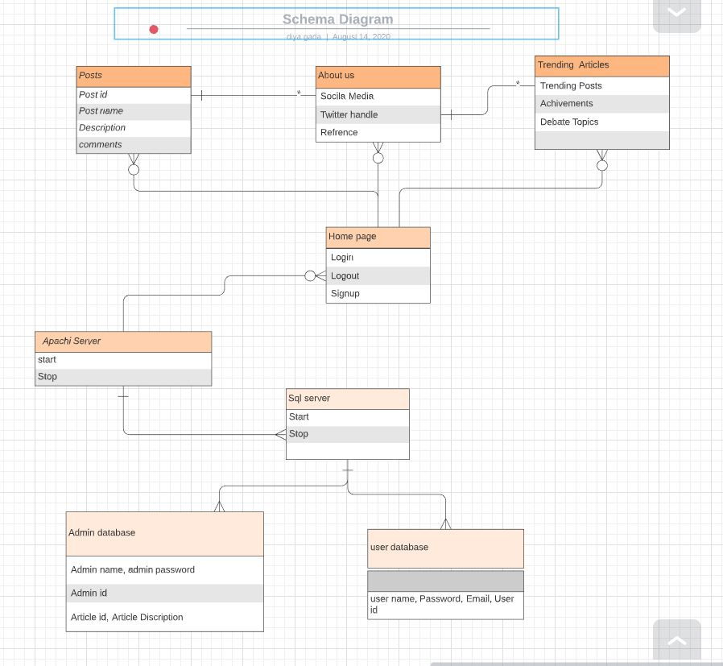

**Chapter 9**

**Coding (Connectivity)**

**-- phpMyAdmin SQL Dump**

**-- version 4.8.0**

**-- https://www.phpmyadmin.net/**

**--**

**-- Host: 127.0.0.1**

**-- Generation Time: Apr 28, 2018 at 04:07 AM**

**-- Server version: 10.1.31-MariaDB**

**-- PHP Version: 7.0.29**

**SET SQL_MODE = "NO_AUTO_VALUE_ON_ZERO";**

**SET AUTOCOMMIT = 0;**

**START TRANSACTION;**

**SET time_zone = "+00:00";**

**/*!40101 SET @OLD_CHARACTER_SET_CLIENT=@@CHARACTER_SET_CLIENT */;**

**/*!40101 SET @OLD_CHARACTER_SET_RESULTS=@@CHARACTER_SET_RESULTS */;**

**/*!40101 SET @OLD_COLLATION_CONNECTION=@@COLLATION_CONNECTION */;**

**/*!40101 SET NAMES utf8mb4 */;**

**--**

**-- Database: `blog_admin_db`**

**--**

**-- --------------------------------------------------------**

**--**

**-- Table structure for table `banner_posts`**

**--**

**CREATE TABLE `banner_posts` (**

**`id` int(10) UNSIGNED NOT NULL,**

**`title` int(10) UNSIGNED NOT NULL,**

**`status` varchar(40) NOT NULL**

**) ENGINE=InnoDB DEFAULT CHARSET=utf8;**

**--**

**-- Dumping data for table `banner_posts`**

**--**

**INSERT INTO `banner_posts` (`id`, `title`, `status`) VALUES**

**(1, 1, 'active');**

**-- --------------------------------------------------------**

**--**

**-- Table structure for table `blogs`**

**--**

**CREATE TABLE `blogs` (**

**`id` int(10) UNSIGNED NOT NULL,**

**`title` varchar(190) NOT NULL,**

**`tags` varchar(40) NOT NULL,**

**`content` text NOT NULL,**

**`photo` varchar(50) NOT NULL,**

**`posted` varchar(40) NOT NULL,**

**`date` date DEFAULT NULL,**

**`author` varchar(40) DEFAULT NULL,**

**`category` varchar(40) NOT NULL**

**) ENGINE=InnoDB DEFAULT CHARSET=utf8;**

**--**

**-- Dumping data for table `blogs`**

**--**

**INSERT INTO `blogs` (`id`, `title`, `tags`, `content`, `photo`, `posted`, `date`, `author`, `category`) VALUES**

**(1, 'Newest Blog and content management', 'blog,php,bootstrap', '63560400_1524778647.jpg', 'draft', NULL, NULL, '5'),**

**(2, 'Benefits of livig in this world', 'life,life tips', '19292400_1524780270.jpg', 'publish', '2018-04-27', 'admin', '2'),**

**(3, 'The future of web developement on earth', 'web,development,earth', '46981800_1524780339.jpg', 'publish', '2018-04-27', 'admin', '3'),**

**(4, 'The subtle art of not giving a fuck-Mark Manson', 'books,reading,novels', '98308700_1524790852.jpg', 'publish', '2018-04-27', 'admin', '2'),**

**(5, 'The challanges of being a writter', 'witting,blogging', ''57894000_1524856026.jpg', 'publish', '2018-04-27', 'etemesi', '4'),**

**(6, 'Why i ventured into writting as a proffesion', 'witting,blogging', '30278600_1524856225.jpg', 'draft', '2018-04-27', 'etemesi', '4');**

**-- --------------------------------------------------------**

**--**

**-- Table structure for table `blog_categories`**

**--**

**CREATE TABLE `blog_categories` (**

**`id` int(10) UNSIGNED NOT NULL,**

**`name` varchar(40) NOT NULL**

**) ENGINE=InnoDB DEFAULT CHARSET=utf8;**

**--**

**-- Dumping data for table `blog_categories`**

**--**

**INSERT INTO `blog_categories` (`id`, `name`) VALUES**

**(1, 'tricks'),**

**(2, 'hacks'),**

**(3, 'offers'),**

**(4, 'promotion'),**

**(5, 'devices'),**

**(6, 'entertainment');**

**-- --------------------------------------------------------**

**--**

**-- Table structure for table `editors_choice`**

**--**

**CREATE TABLE `editors_choice` (**

**`id` int(10) UNSIGNED NOT NULL,**

**`blog` int(10) UNSIGNED NOT NULL**

**) ENGINE=InnoDB DEFAULT CHARSET=utf8;**

**--**

**-- Dumping data for table `editors_choice`**

**--**

**INSERT INTO `editors_choice` (`id`, `blog`) VALUES**

**(2, 3),**

**(1, 4);**

**-- --------------------------------------------------------**

**--**

**-- Table structure for table `links`**

**--**

**CREATE TABLE `links` (**

**`id` int(10) UNSIGNED NOT NULL,**

**`facebook` varchar(40) DEFAULT NULL,**

**`twitter` varchar(40) DEFAULT NULL,**

**`googleplus` varchar(40) DEFAULT NULL,**

**`pinterest` varchar(40) DEFAULT NULL,**

**`dribble` varchar(40) DEFAULT NULL,**

**`comments_script` text,**

**`sharing_script` text,**

**`javascript` text**

**) ENGINE=InnoDB DEFAULT CHARSET=utf8;**

**--**

**-- Dumping data for table `links`**

**--**

**INSERT INTO `links` (`id`, `facebook`, `twitter`, `googleplus`, `pinterest`, `dribble`, `comments_script`, `sharing_script`, `javascript`) VALUES**

**(1, 'http://www.facebook.com', 'http://www.twitter.com', 'http://www.plus.google.com', 'http://www.pinterest.com', 'http://www.dribble.com');**

**-- --------------------------------------------------------**

**--**

**-- Table structure for table `membership_grouppermissions`**

**--**

**CREATE TABLE `membership_grouppermissions` (**

**`permissionID` int(10) UNSIGNED NOT NULL,**

**`groupID` int(11) DEFAULT NULL,**

**`tableName` varchar(100) DEFAULT NULL,**

**`allowInsert` tinyint(4) DEFAULT NULL,**

**`allowView` tinyint(4) NOT NULL DEFAULT '0',**

**`allowEdit` tinyint(4) NOT NULL DEFAULT '0',**

**`allowDelete` tinyint(4) NOT NULL DEFAULT '0'**

**) ENGINE=InnoDB DEFAULT CHARSET=utf8;**

**--**

**-- Dumping data for table `membership_grouppermissions`**

**--**

**INSERT INTO `membership_grouppermissions` (`permissionID`, `groupID`, `tableName`, `allowInsert`, `allowView`, `allowEdit`, `allowDelete`) VALUES**

**(1, 2, 'titles', 1, 3, 3, 3),**

**(2, 2, 'links', 1, 3, 3, 3),**

**(3, 2, 'blog_categories', 1, 3, 3, 3),**

**(4, 2, 'blogs', 1, 3, 3, 3),**

**(5, 2, 'banner_posts', 1, 3, 3, 3),**

**(6, 2, 'editors_choice', 1, 3, 3, 3),**

**(32, 3, 'titles', 0, 0, 0, 0),**

**(33, 3, 'links', 0, 0, 0, 0),**

**(34, 3, 'blog_categories', 0, 3, 0, 0),**

**(35, 3, 'blogs', 1, 1, 1, 1),**

**(36, 3, 'editors_choice', 0, 0, 0, 0);**

**-- --------------------------------------------------------**

**--**

**-- Table structure for table `membership_groups`**

**--**

**CREATE TABLE `membership_groups` (**

**`groupID` int(10) UNSIGNED NOT NULL,**

**`name` varchar(20) DEFAULT NULL,**

**`description` text,**

**`allowSignup` tinyint(4) DEFAULT NULL,**

**`needsApproval` tinyint(4) DEFAULT NULL**

**) ENGINE=InnoDB DEFAULT CHARSET=utf8;**

**--**

**-- Dumping data for table `membership_groups`**

**--**

**INSERT INTO `membership_groups` (`groupID`, `name`, `description`, `allowSignup`, `needsApproval`) VALUES**

**(1, 'anonymous', 'Anonymous group created automatically on 2018-04-26', 0, 0),**

**(2, 'Admins', 'Admin group created automatically on 2018-04-26', 0, 1),**

**(3, 'authors', 'contains all the guest authors', 1, 0);**

**-- --------------------------------------------------------**

**--**

**-- Table structure for table `membership_userpermissions`**

**--**

**CREATE TABLE `membership_userpermissions` (**

**`permissionID` int(10) UNSIGNED NOT NULL,**

**`memberID` varchar(20) NOT NULL,**

**`tableName` varchar(100) DEFAULT NULL,**

**`allowInsert` tinyint(4) DEFAULT NULL,**

**`allowView` tinyint(4) NOT NULL DEFAULT '0',**

**`allowEdit` tinyint(4) NOT NULL DEFAULT '0',**

**`allowDelete` tinyint(4) NOT NULL DEFAULT '0'**

**) ENGINE=InnoDB DEFAULT CHARSET=utf8;**

**-- --------------------------------------------------------**

**--**

**-- Table structure for table `membership_userrecords`**

**--**

**CREATE TABLE `membership_userrecords` (**

**`recID` bigint(20) UNSIGNED NOT NULL,**

**`tableName` varchar(100) DEFAULT NULL,**

**`pkValue` varchar(255) DEFAULT NULL,**

**`memberID` varchar(20) DEFAULT NULL,**

**`dateAdded` bigint(20) UNSIGNED DEFAULT NULL,**

**`dateUpdated` bigint(20) UNSIGNED DEFAULT NULL,**

**`groupID` int(11) DEFAULT NULL**

**) ENGINE=InnoDB DEFAULT CHARSET=utf8;**

**--**

**-- Dumping data for table `membership_userrecords`**

**--**

**INSERT INTO `membership_userrecords` (`recID`, `tableName`, `pkValue`, `memberID`, `dateAdded`, `dateUpdated`, `groupID`) VALUES**

**(1, 'titles', '1', 'admin', 1524766759, 1524868561, 2),**

**(2, 'links', '1', 'admin', 1524766827, 1524878963, 2),**

**(3, 'blog_categories', '1', 'admin', 1524773915, 1524773915, 2),**

**(4, 'blog_categories', '2', 'admin', 1524773923, 1524773923, 2),**

**(5, 'blog_categories', '3', 'admin', 1524773931, 1524773931, 2),**

**(6, 'blog_categories', '4', 'admin', 1524773941, 1524773941, 2),**

**(7, 'blog_categories', '5', 'admin', 1524773974, 1524773974, 2),**

**(8, 'blogs', '1', 'admin', 1524778647, 1524791344, 2),**

**(9, 'banner_posts', '1', 'admin', 1524779492, 1524779492, 2),**

**(10, 'blogs', '2', 'admin', 1524780270, 1524781513, 2),**

**(11, 'blogs', '3', 'admin', 1524780339, 1524789616, 2),**

**(12, 'blogs', '4', 'admin', 1524790853, 1524790853, 2),**

**(13, 'editors_choice', '1', 'admin', 1524799889, 1524799889, 2),**

**(14, 'editors_choice', '2', 'admin', 1524799903, 1524799903, 2),**

**(15, 'blogs', '5', 'etemesi', 1524856026, 1524856026, 3),**

**(16, 'blogs', '6', 'etemesi', 1524856225, 1524856225, 3),**

**(17, 'blog_categories', '6', 'etemesi', 1524858044, 1524858044, 3);**

**-- --------------------------------------------------------**

**--**

**-- Table structure for table `membership_users`**

**--**

**CREATE TABLE `membership_users` (**

**`memberID` varchar(20) NOT NULL,**

**`passMD5` varchar(40) DEFAULT NULL,**

**`email` varchar(100) DEFAULT NULL,**

**`signupDate` date DEFAULT NULL,**

**`groupID` int(10) UNSIGNED DEFAULT NULL,**

**`isBanned` tinyint(4) DEFAULT NULL,**

**`isApproved` tinyint(4) DEFAULT NULL,**

**`custom1` text,**

**`custom2` text,**

**`custom3` text,**

**`custom4` text,**

**`comments` text,**

**`pass_reset_key` varchar(100) DEFAULT NULL,**

**`pass_reset_expiry` int(10) UNSIGNED DEFAULT NULL**

**) ENGINE=InnoDB DEFAULT CHARSET=utf8;**

**--**

**-- Dumping data for table `membership_users`**

**--**

**INSERT INTO `membership_users` (`memberID`, `passMD5`, `email`, `signupDate`, `groupID`, `isBanned`, `isApproved`, `custom1`, `custom2`, `custom3`, `custom4`, `comments`, `pass_reset_key`, `pass_reset_expiry`) VALUES**

**('admin', '21232f297a57a5a743894a0e4a801fc3', 'ronniengoda@gmail.com', '2018-04-26', 2, 0, 1, NULL, NULL, NULL, NULL, 'Admin member created automatically on 2018-04-26\nRecord updated automatically on 2018-04-27', NULL, NULL),**

**('etemesi', '827ccb0eea8a706c4c34a16891f84e7b', 'etemesi@gmail.com', '2018-04-27', 3, 0, 1, 'philiiip etemesi', 'nairobi,kenya', 'nairobi', 'kenya', 'member signed up through the registration form.', NULL, NULL),**

**('guest', NULL, NULL, '2018-04-26', 1, 0, 1, NULL, NULL, NULL, NULL, 'Anonymous member created automatically on 2018-04-26', NULL, NULL);**

**-- --------------------------------------------------------**

**--**

**-- Table structure for table `page_hits`**

**--**

**CREATE TABLE `page_hits` (**

**`page` varchar(255) NOT NULL,**

**`count` int(11) DEFAULT NULL**

**) ENGINE=InnoDB DEFAULT CHARSET=latin1;**

**--**

**-- Dumping data for table `page_hits`**

**--**

**INSERT INTO `page_hits` (`page`, `count`) VALUES**

**('Benefits of livig in this world', 6),**

**('The challanges of being a writter', 5),**

**('The future of web developement on earth', 19),**

**('The subtle art of not giving a fuck-Mark Manson', 22),**

**('Why i ventured into writting as a proffesion', 2);**

**-- --------------------------------------------------------**

**--**

**-- Table structure for table `titles`**

**--**

**CREATE TABLE `titles` (**

**`id` int(10) UNSIGNED NOT NULL,**

**`website_name` varchar(40) DEFAULT NULL,**

**`tagline` varchar(40) DEFAULT NULL,**

**`icon` varchar(40) DEFAULT NULL,**

**`keywords` varchar(220) DEFAULT NULL,**

**`short_description` varchar(200) DEFAULT NULL,**

**`bannertext1` varchar(150) DEFAULT NULL,**

**`bannertext2` varchar(150) DEFAULT NULL,**

**`bannertext3` varchar(150) DEFAULT NULL,**

**`bannertext4` varchar(150) DEFAULT NULL,**

**`detailed_description` text,**

**`address` varchar(40) DEFAULT NULL,**

**`email` varchar(80) DEFAULT NULL,**

**`phone` varchar(40) DEFAULT NULL,**

**`googlemap` varchar(255) DEFAULT NULL**

**) ENGINE=InnoDB DEFAULT CHARSET=utf8;**

**--**

**-- Dumping data for table `titles`**

**--**

**INSERT INTO `titles` (`id`, `website_name`, `tagline`, `icon`, `keywords`, `short_description`, `bannertext1`, `bannertext2`, `bannertext3`, `bannertext4`, `detailed_description`, `address`, `email`, `phone`, `googlemap`) VALUES**

**(1, 'Responsive Blog', 'Blogging For Passion', '95401600_1524766758.jpg', 'blog,tech blog,tricks,hacks,technology news,fantastic blog', 'This is a blog and content management system,You can easily setup your blog and customize it according to your needs.This is a short description of your blog.You can change this', 'Create a lifestyle contribute content.Lorem ipsum dolor sit amet, consectetur adipisicing elit, sed do eiusmodtempor incididunt ut labore et dolore magna aliqua. Ut enim ad minim veniam,quis nostrud exercitation ullamco laboris nisi ut aliquip ex ea commodoconsequat. Duis aute irure dolor in reprehenderit in voluptate velit essecillum dolore eu fugiat nulla pariatur. Excepteur sint occaecat cupidatat nonproident, sunt in culpa qui officia deserunt mollit anim id est laborum.', 'Nairobi,Kenya', 'info@fantasticblog.com', '0708344101', 'https://www.google.com/maps/embed?pb=!1m18!1m12!1m3!1d100949.24429313939!2d-122.44206553967531!3d37.75102885910819!2m3!1f0!2f0!3f0!3m2!1i1024!2i768!4f13.1!3m3!1m2!1s0x80859a6d00690021%3A0x4a501367f076adff!2sSan+Francisco%2C+CA%2C+USA!5e0!3m2!1sen!2sin!4v1');**

**-- --------------------------------------------------------**

**--**

**-- Table structure for table `visitor_info`**

**--**

**CREATE TABLE `visitor_info` (**

**`id` int(11) NOT NULL,**

**`ip_address` varchar(255) DEFAULT NULL,**

**`user_agent` varchar(255) DEFAULT NULL,**

**`time_accessed` timestamp NOT NULL DEFAULT CURRENT_TIMESTAMP**

**) ENGINE=InnoDB DEFAULT CHARSET=latin1;**

**--**

**-- Dumping data for table `visitor_info`**

**--**

**INSERT INTO `visitor_info` (`id`, `ip_address`, `user_agent`, `time_accessed`) VALUES**

**(1, '::1', 'Mozilla/5.0 (Windows NT 10.0; Win64; x64) AppleWebKit/537.36 (KHTML, like Gecko) Chrome/66.0.3359.117 Safari/537.36', '2018-04-27 16:26:52'),**

**(2, '::1', 'Mozilla/5.0 (Windows NT 10.0; Win64; x64) AppleWebKit/537.36 (KHTML, like Gecko) Chrome/66.0.3359.117 Safari/537.36', '2018-04-27 16:27:01'),**

**(3, '::1', 'Mozilla/5.0 (Windows NT 10.0; Win64; x64) AppleWebKit/537.36 (KHTML, like Gecko) Chrome/66.0.3359.117 Safari/537.36', '2018-04-27 16:27:40'),**

**(4, '::1', 'Mozilla/5.0 (Windows NT 10.0; Win64; x64) AppleWebKit/537.36 (KHTML, like Gecko) Chrome/66.0.3359.117 Safari/537.36', '2018-04-27 16:27:55'),**

**(5, '::1', 'Mozilla/5.0 (Windows NT 10.0; Win64; x64) AppleWebKit/537.36 (KHTML, like Gecko) Chrome/66.0.3359.117 Safari/537.36', '2018-04-27 16:28:01'),**

**(6, '::1', 'Mozilla/5.0 (Windows NT 10.0; Win64; x64) AppleWebKit/537.36 (KHTML, like Gecko) Chrome/66.0.3359.117 Safari/537.36', '2018-04-27 16:28:12'),**

**(7, '::1', 'Mozilla/5.0 (Windows NT 10.0; Win64; x64) AppleWebKit/537.36 (KHTML, like Gecko) Chrome/66.0.3359.117 Safari/537.36', '2018-04-27 16:28:19'),**

**(8, '::1', 'Mozilla/5.0 (Windows NT 10.0; Win64; x64) AppleWebKit/537.36 (KHTML, like Gecko) Chrome/66.0.3359.117 Safari/537.36', '2018-04-27 16:28:22'),**

**(9, '::1', 'Mozilla/5.0 (Windows NT 10.0; Win64; x64) AppleWebKit/537.36 (KHTML, like Gecko) Chrome/66.0.3359.117 Safari/537.36', '2018-04-27 16:28:29'),**

**(10, '::1', 'Mozilla/5.0 (Windows NT 10.0; Win64; x64) AppleWebKit/537.36 (KHTML, like Gecko) Chrome/66.0.3359.117 Safari/537.36', '2018-04-27 16:28:32'),**

**(11, '::1', 'Mozilla/5.0 (Windows NT 10.0; Win64; x64) AppleWebKit/537.36 (KHTML, like Gecko) Chrome/66.0.3359.117 Safari/537.36', '2018-04-27 16:28:35'),**

**(12, '::1', 'Mozilla/5.0 (Windows NT 10.0; Win64; x64) AppleWebKit/537.36 (KHTML, like Gecko) Chrome/66.0.3359.117 Safari/537.36', '2018-04-27 16:28:38'),**

**(13, '::1', 'Mozilla/5.0 (Windows NT 10.0; Win64; x64) AppleWebKit/537.36 (KHTML, like Gecko) Chrome/66.0.3359.117 Safari/537.36', '2018-04-27 16:29:05'),**

**(14, '::1', 'Mozilla/5.0 (Windows NT 10.0; Win64; x64) AppleWebKit/537.36 (KHTML, like Gecko) Chrome/66.0.3359.117 Safari/537.36', '2018-04-27 16:29:09'),**

**(15, '::1', 'Mozilla/5.0 (Windows NT 10.0; Win64; x64) AppleWebKit/537.36 (KHTML, like Gecko) Chrome/66.0.3359.117 Safari/537.36', '2018-04-27 16:29:18'),**

**(16, '::1', 'Mozilla/5.0 (Windows NT 10.0; Win64; x64) AppleWebKit/537.36 (KHTML, like Gecko) Chrome/66.0.3359.117 Safari/537.36', '2018-04-27 16:29:25'),**

**(17, '::1', 'Mozilla/5.0 (Windows NT 10.0; Win64; x64) AppleWebKit/537.36 (KHTML, like Gecko) Chrome/66.0.3359.117 Safari/537.36', '2018-04-27 16:29:28'),**

**(18, '::1', 'Mozilla/5.0 (Windows NT 10.0; Win64; x64) AppleWebKit/537.36 (KHTML, like Gecko) Chrome/66.0.3359.117 Safari/537.36', '2018-04-27 16:29:51'),**

**(19, '::1', 'Mozilla/5.0 (Windows NT 10.0; Win64; x64) AppleWebKit/537.36 (KHTML, like Gecko) Chrome/66.0.3359.117 Safari/537.36', '2018-04-27 16:29:57'),**

**(20, '::1', 'Mozilla/5.0 (Windows NT 10.0; Win64; x64) AppleWebKit/537.36 (KHTML, like Gecko) Chrome/66.0.3359.117 Safari/537.36', '2018-04-27 16:30:00'),**

**(21, '::1', 'Mozilla/5.0 (Windows NT 10.0; Win64; x64) AppleWebKit/537.36 (KHTML, like Gecko) Chrome/66.0.3359.117 Safari/537.36', '2018-04-27 16:30:07'),**

**(22, '::1', 'Mozilla/5.0 (Windows NT 10.0; Win64; x64) AppleWebKit/537.36 (KHTML, like Gecko) Chrome/66.0.3359.117 Safari/537.36', '2018-04-27 16:30:15'),**

**(23, '::1', 'Mozilla/5.0 (Windows NT 10.0; Win64; x64) AppleWebKit/537.36 (KHTML, like Gecko) Chrome/66.0.3359.117 Safari/537.36', '2018-04-27 16:39:41'),**

**(24, '::1', 'Mozilla/5.0 (Windows NT 10.0; Win64; x64) AppleWebKit/537.36 (KHTML, like Gecko) Chrome/66.0.3359.117 Safari/537.36', '2018-04-27 16:40:41'),**

**(25, '::1', 'Mozilla/5.0 (Windows NT 10.0; Win64; x64) AppleWebKit/537.36 (KHTML, like Gecko) Chrome/66.0.3359.117 Safari/537.36', '2018-04-27 16:41:27'),**

**(26, '::1', 'Mozilla/5.0 (Windows NT 10.0; Win64; x64) AppleWebKit/537.36 (KHTML, like Gecko) Chrome/66.0.3359.117 Safari/537.36', '2018-04-27 17:26:10'),**

**(27, '::1', 'Mozilla/5.0 (Windows NT 10.0; Win64; x64) AppleWebKit/537.36 (KHTML, like Gecko) Chrome/66.0.3359.117 Safari/537.36', '2018-04-27 17:27:34'),**

**(35, '::1', 'Mozilla/5.0 (Windows NT 10.0; Win64; x64) AppleWebKit/537.36 (KHTML, like Gecko) Chrome/66.0.3359.117 Safari/537.36', '2018-04-27 17:30:48'),**

**(36, '::1', 'Mozilla/5.0 (Windows NT 10.0; Win64; x64) AppleWebKit/537.36 (KHTML, like Gecko) Chrome/66.0.3359.117 Safari/537.36', '2018-04-27 17:30:51'),**

**(37, '::1', 'Mozilla/5.0 (Windows NT 10.0; Win64; x64) AppleWebKit/537.36 (KHTML, like Gecko) Chrome/66.0.3359.117 Safari/537.36', '2018-04-27 17:30:53'),**

**(38, '::1', 'Mozilla/5.0 (Windows NT 10.0; Win64; x64) AppleWebKit/537.36 (KHTML, like Gecko) Chrome/66.0.3359.117 Safari/537.36', '2018-04-27 17:30:56'),**

**(39, '::1', 'Mozilla/5.0 (Windows NT 10.0; Win64; x64) AppleWebKit/537.36 (KHTML, like Gecko) Chrome/66.0.3359.117 Safari/537.36', '2018-04-27 17:30:59'),**

**(40, '::1', 'Mozilla/5.0 (Windows NT 10.0; Win64; x64) AppleWebKit/537.36 (KHTML, like Gecko) Chrome/66.0.3359.117 Safari/537.36', '2018-04-27 17:32:02'),**

**(41, '::1', 'Mozilla/5.0 (Windows NT 10.0; Win64; x64) AppleWebKit/537.36 (KHTML, like Gecko) Chrome/66.0.3359.117 Safari/537.36', '2018-04-27 17:32:05'),**

**(42, '::1', 'Mozilla/5.0 (Windows NT 10.0; Win64; x64) AppleWebKit/537.36 (KHTML, like Gecko) Chrome/66.0.3359.117 Safari/537.36', '2018-04-27 17:32:07'),**

**(43, '::1', 'Mozilla/5.0 (Windows NT 10.0; Win64; x64) AppleWebKit/537.36 (KHTML, like Gecko) Chrome/66.0.3359.117 Safari/537.36', '2018-04-27 17:32:10'),**

**(44, '::1', 'Mozilla/5.0 (Windows NT 10.0; Win64; x64) AppleWebKit/537.36 (KHTML, like Gecko) Chrome/66.0.3359.117 Safari/537.36', '2018-04-27 19:08:04'),**

**(45, '::1', 'Mozilla/5.0 (Windows NT 10.0; Win64; x64) AppleWebKit/537.36 (KHTML, like Gecko) Chrome/66.0.3359.117 Safari/537.36', '2018-04-27 19:08:14'),**

**(46, '::1', 'Mozilla/5.0 (Windows NT 10.0; Win64; x64) AppleWebKit/537.36 (KHTML, like Gecko) Chrome/66.0.3359.117 Safari/537.36', '2018-04-27 21:43:06'),**

**(47, '::1', 'Mozilla/5.0 (Windows NT 10.0; Win64; x64) AppleWebKit/537.36 (KHTML, like Gecko) Chrome/66.0.3359.117 Safari/537.36', '2018-04-27 21:47:01'),**

**(48, '::1', 'Mozilla/5.0 (Windows NT 10.0; Win64; x64) AppleWebKit/537.36 (KHTML, like Gecko) Chrome/66.0.3359.117 Safari/537.36', '2018-04-27 21:47:08'),**

**(49, '::1', 'Mozilla/5.0 (Windows NT 10.0; Win64; x64) AppleWebKit/537.36 (KHTML, like Gecko) Chrome/66.0.3359.117 Safari/537.36', '2018-04-27 21:48:58'),**

**(50, '::1', 'Mozilla/5.0 (Windows NT 10.0; Win64; x64) AppleWebKit/537.36 (KHTML, like Gecko) Chrome/66.0.3359.117 Safari/537.36', '2018-04-27 21:49:18'),**

**(51, '::1', 'Mozilla/5.0 (Windows NT 10.0; Win64; x64) AppleWebKit/537.36 (KHTML, like Gecko) Chrome/66.0.3359.117 Safari/537.36', '2018-04-27 22:22:28'),**

**(52, '::1', 'Mozilla/5.0 (Windows NT 10.0; Win64; x64) AppleWebKit/537.36 (KHTML, like Gecko) Chrome/66.0.3359.117 Safari/537.36', '2018-04-28 01:41:41'),**

**(53, '::1', 'Mozilla/5.0 (Windows NT 10.0; Win64; x64) AppleWebKit/537.36 (KHTML, like Gecko) Chrome/66.0.3359.117 Safari/537.36', '2018-04-28 01:43:58'),**

**(54, '::1', 'Mozilla/5.0 (Windows NT 10.0; Win64; x64) AppleWebKit/537.36 (KHTML, like Gecko) Chrome/66.0.3359.117 Safari/537.36', '2018-04-28 01:46:23');**

**--**

**-- Indexes for dumped tables**

**--**

**--**

**-- Indexes for table `banner_posts`**

**--**

**ALTER TABLE `banner_posts`**

**ADD PRIMARY KEY (`id`),**

**ADD KEY `title` (`title`);**

**--**

**-- Indexes for table `blogs`**

**--**

**ALTER TABLE `blogs`**

**ADD PRIMARY KEY (`id`),**

**ADD KEY `category` (`category`);**

**--**

**-- Indexes for table `blog_categories`**

**--**

**ALTER TABLE `blog_categories`**

**ADD PRIMARY KEY (`id`);**

**--**

**-- Indexes for table `editors_choice`**

**--**

**ALTER TABLE `editors_choice`**

**ADD PRIMARY KEY (`id`),**

**ADD KEY `blog` (`blog`);**

**--**

**-- Indexes for table `links`**

**--**

**ALTER TABLE `links`**

**ADD PRIMARY KEY (`id`);**

**--**

**-- Indexes for table `membership_grouppermissions`**

**--**

**ALTER TABLE `membership_grouppermissions`**

**ADD PRIMARY KEY (`permissionID`);**

**--**

**-- Indexes for table `membership_groups`**

**--**

**ALTER TABLE `membership_groups`**

**ADD PRIMARY KEY (`groupID`);**

**--**

**-- Indexes for table `membership_userpermissions`**

**--**

**ALTER TABLE `membership_userpermissions`**

**ADD PRIMARY KEY (`permissionID`);**

**--**

**-- Indexes for table `membership_userrecords`**

**--**

**ALTER TABLE `membership_userrecords`**

**ADD PRIMARY KEY (`recID`),**

**ADD UNIQUE KEY `tableName_pkValue` (`tableName`,`pkValue`),**

**ADD KEY `pkValue` (`pkValue`),**

**ADD KEY `tableName` (`tableName`),**

**ADD KEY `memberID` (`memberID`),**

**ADD KEY `groupID` (`groupID`);**

**--**

**-- Indexes for table `membership_users`**

**--**

**ALTER TABLE `membership_users`**

**ADD PRIMARY KEY (`memberID`),**

**ADD KEY `groupID` (`groupID`);**

**--**

**-- Indexes for table `page_hits`**

**--**

**ALTER TABLE `page_hits`**

**ADD PRIMARY KEY (`page`);**

**--**

**-- Indexes for table `titles`**

**--**

**ALTER TABLE `titles`**

**ADD PRIMARY KEY (`id`);**

**--**

**-- Indexes for table `visitor_info`**

**--**

**ALTER TABLE `visitor_info`**

**ADD PRIMARY KEY (`id`);**

**--**

**-- AUTO_INCREMENT for dumped tables**

**--**

**--**

**-- AUTO_INCREMENT for table `banner_posts`**

**--**

**ALTER TABLE `banner_posts`**

**MODIFY `id` int(10) UNSIGNED NOT NULL AUTO_INCREMENT, AUTO_INCREMENT=2;**

**--**

**-- AUTO_INCREMENT for table `blogs`**

**--**

**ALTER TABLE `blogs`**

**MODIFY `id` int(10) UNSIGNED NOT NULL AUTO_INCREMENT, AUTO_INCREMENT=7;**

**--**

**-- AUTO_INCREMENT for table `blog_categories`**

**--**

**ALTER TABLE `blog_categories`**

**MODIFY `id` int(10) UNSIGNED NOT NULL AUTO_INCREMENT, AUTO_INCREMENT=7;**

**--**

**-- AUTO_INCREMENT for table `editors_choice`**

**--**

**ALTER TABLE `editors_choice`**

**MODIFY `id` int(10) UNSIGNED NOT NULL AUTO_INCREMENT, AUTO_INCREMENT=3;**

**--**

**-- AUTO_INCREMENT for table `links`**

**--**

**ALTER TABLE `links`**

**MODIFY `id` int(10) UNSIGNED NOT NULL AUTO_INCREMENT, AUTO_INCREMENT=2;**

**--**

**-- AUTO_INCREMENT for table `membership_grouppermissions`**

**--**

**ALTER TABLE `membership_grouppermissions`**

**MODIFY `permissionID` int(10) UNSIGNED NOT NULL AUTO_INCREMENT, AUTO_INCREMENT=37;**

**--**

**-- AUTO_INCREMENT for table `membership_groups`**

**--**

**ALTER TABLE `membership_groups`**

**MODIFY `groupID` int(10) UNSIGNED NOT NULL AUTO_INCREMENT, AUTO_INCREMENT=4;**

**--**

**-- AUTO_INCREMENT for table `membership_userpermissions`**

**--**

**ALTER TABLE `membership_userpermissions`**

**MODIFY `permissionID` int(10) UNSIGNED NOT NULL AUTO_INCREMENT;**

**--**

**-- AUTO_INCREMENT for table `membership_userrecords`**

**--**

**ALTER TABLE `membership_userrecords`**

**MODIFY `recID` bigint(20) UNSIGNED NOT NULL AUTO_INCREMENT, AUTO_INCREMENT=18;**

**--**

**-- AUTO_INCREMENT for table `titles`**

**--**

**ALTER TABLE `titles`**

**MODIFY `id` int(10) UNSIGNED NOT NULL AUTO_INCREMENT, AUTO_INCREMENT=2;**

**--**

**-- AUTO_INCREMENT for table `visitor_info`**

**--**

**ALTER TABLE `visitor_info`**

**MODIFY `id` int(11) NOT NULL AUTO_INCREMENT, AUTO_INCREMENT=55;**

**COMMIT;**

**/*!40101 SET CHARACTER_SET_CLIENT=@OLD_CHARACTER_SET_CLIENT */;**

**/*!40101 SET CHARACTER_SET_RESULTS=@OLD_CHARACTER_SET_RESULTS */;**

**Chapter 10**

**Screenshots**

**Home page**

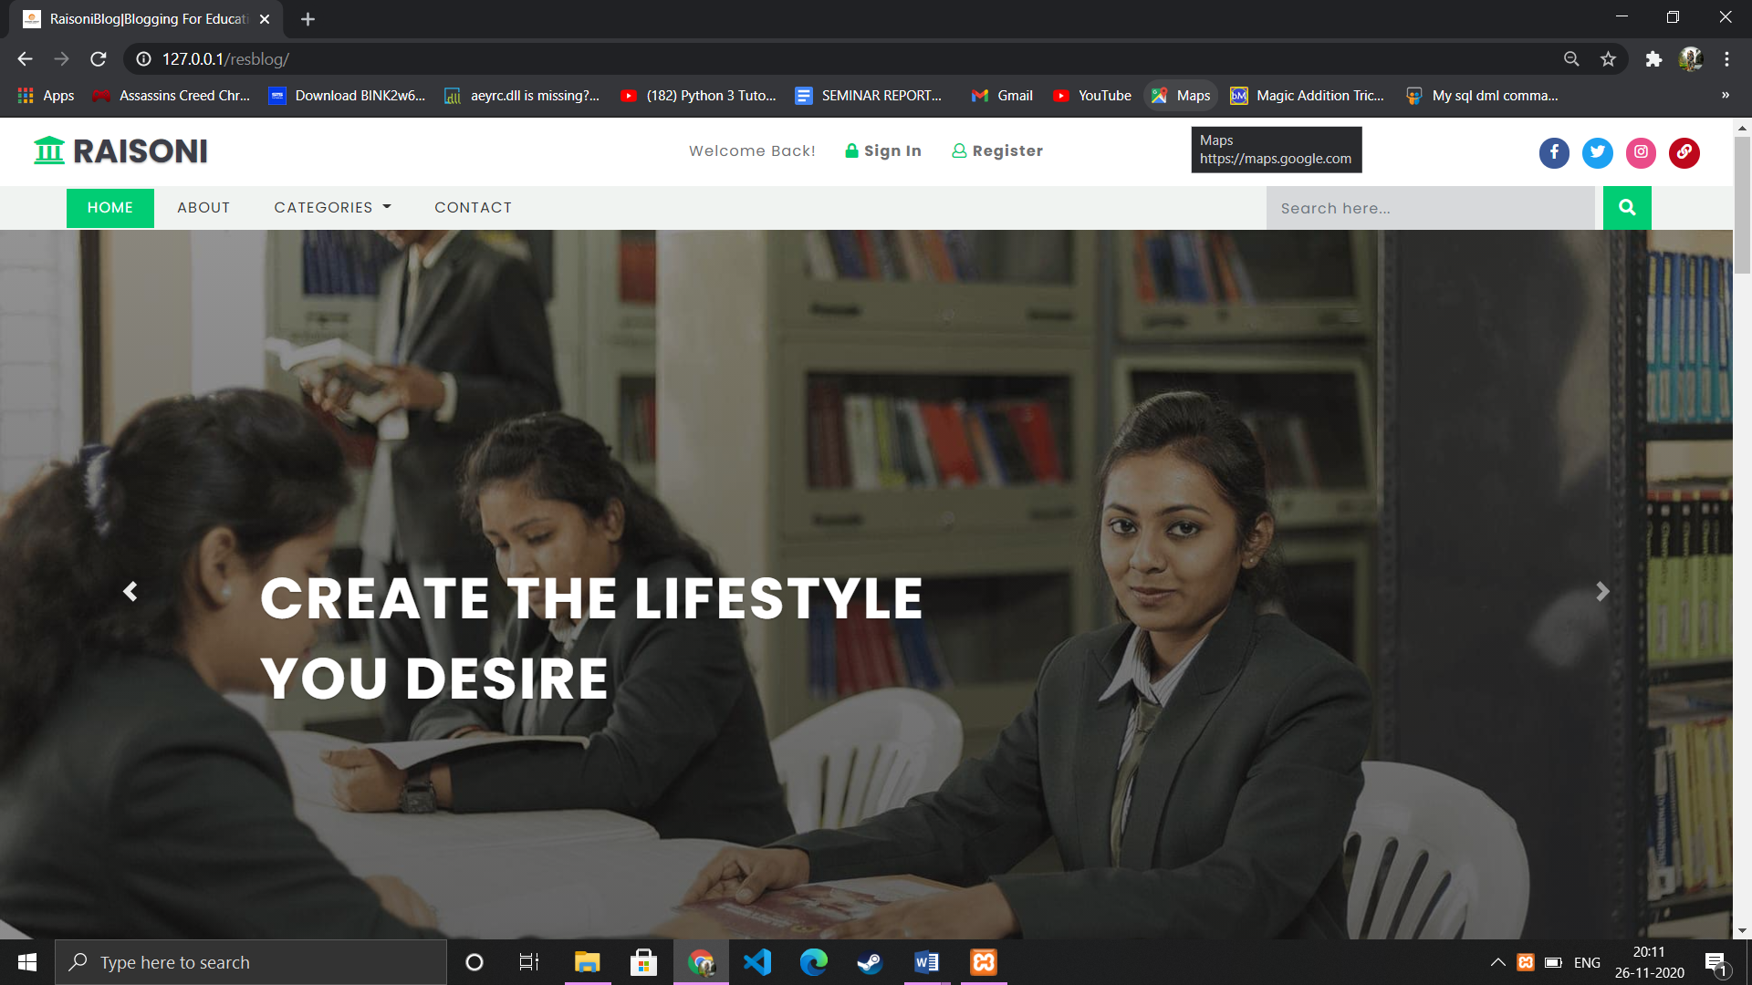

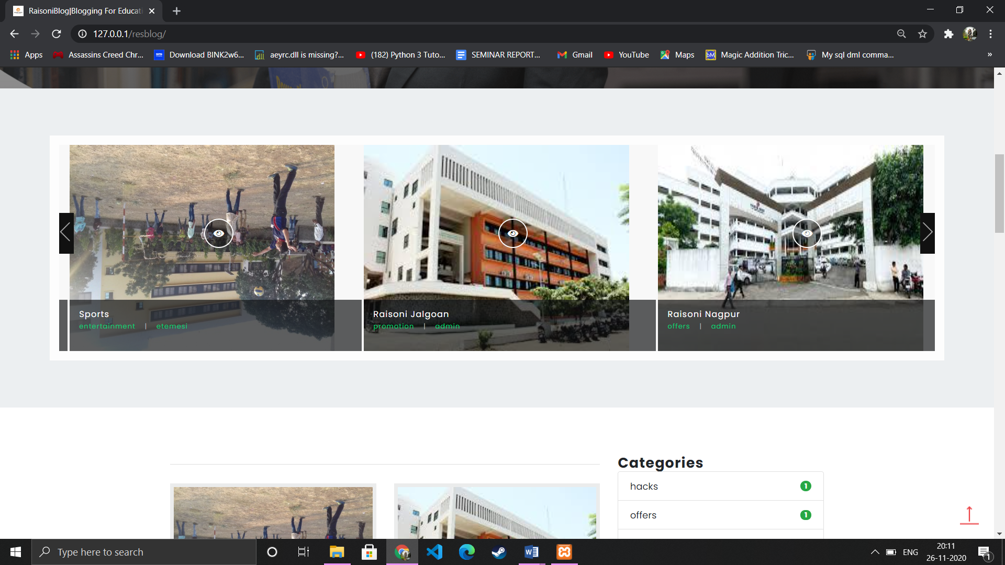

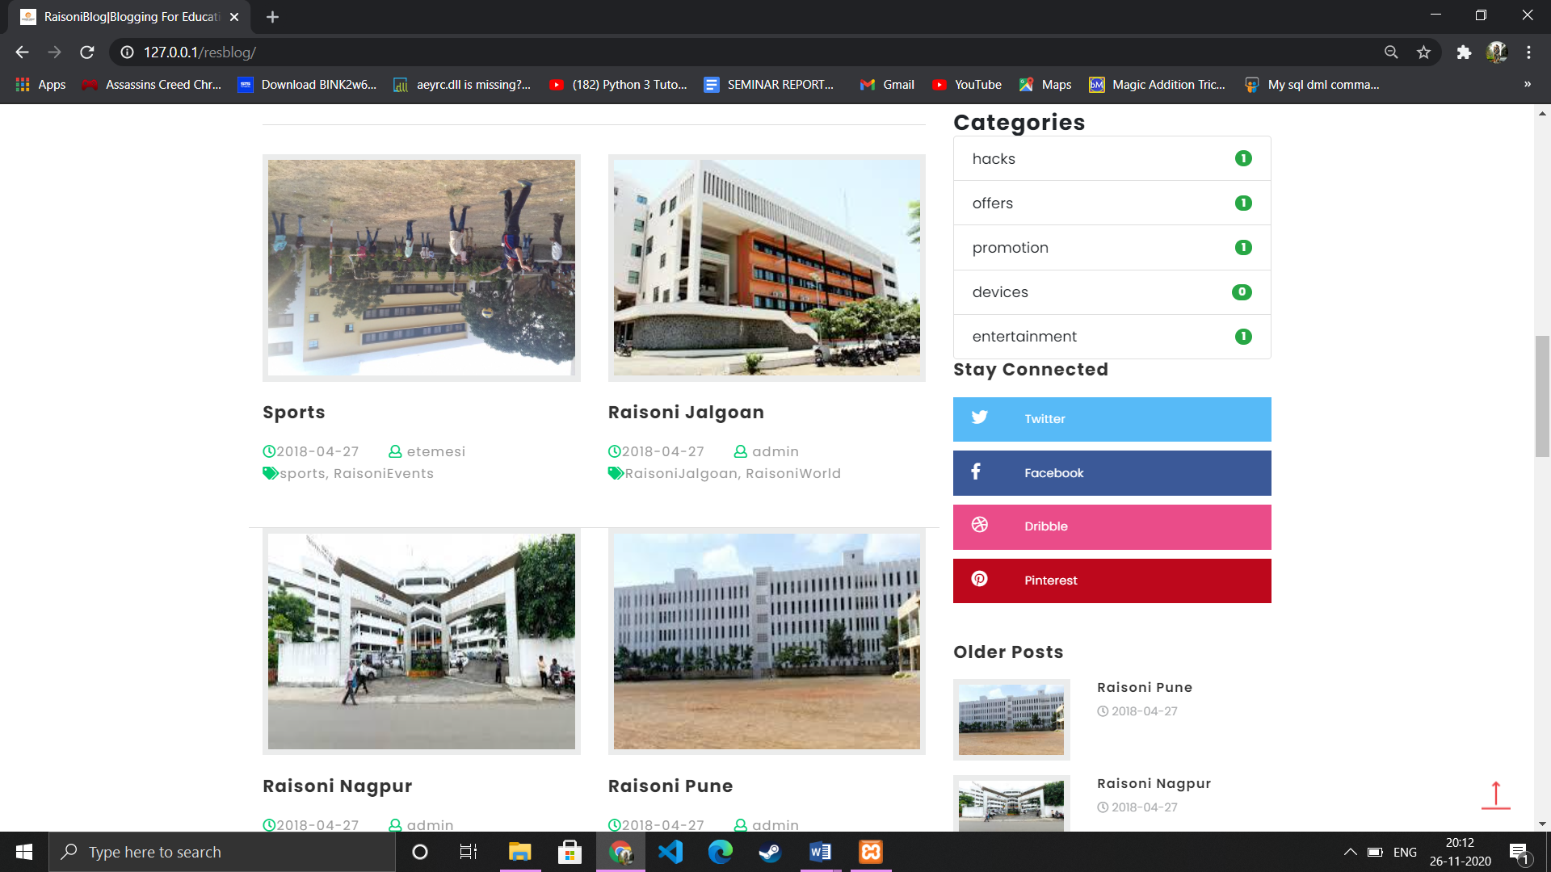

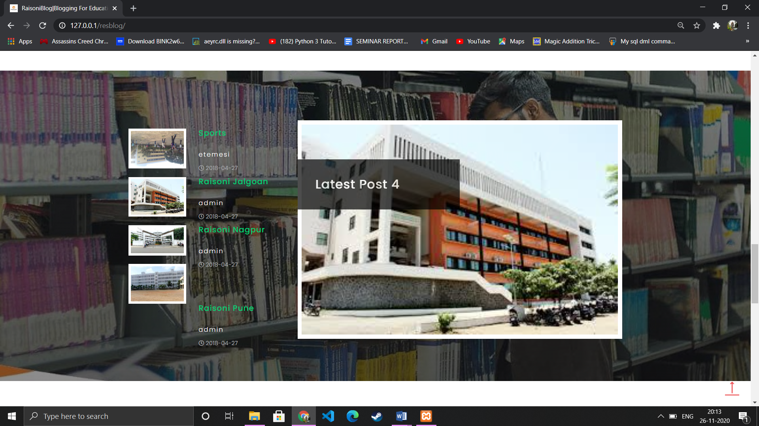

**Blog post page**

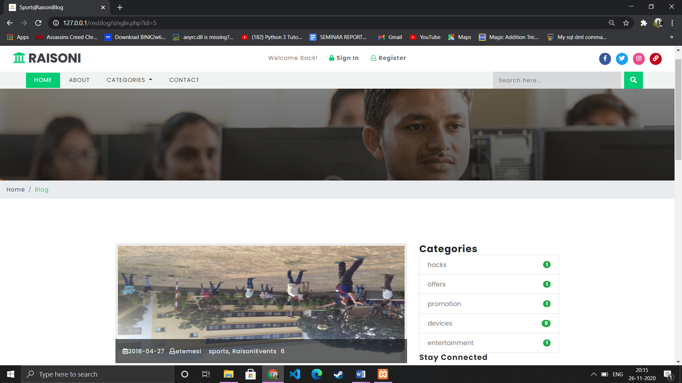

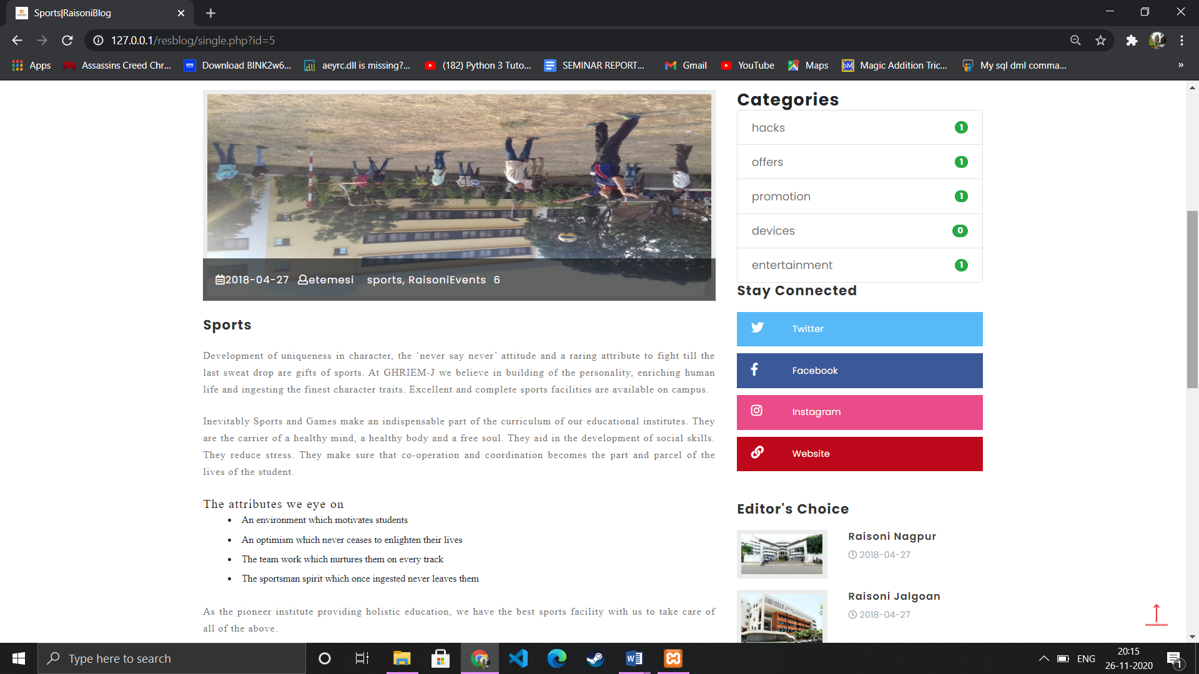

**Register page**

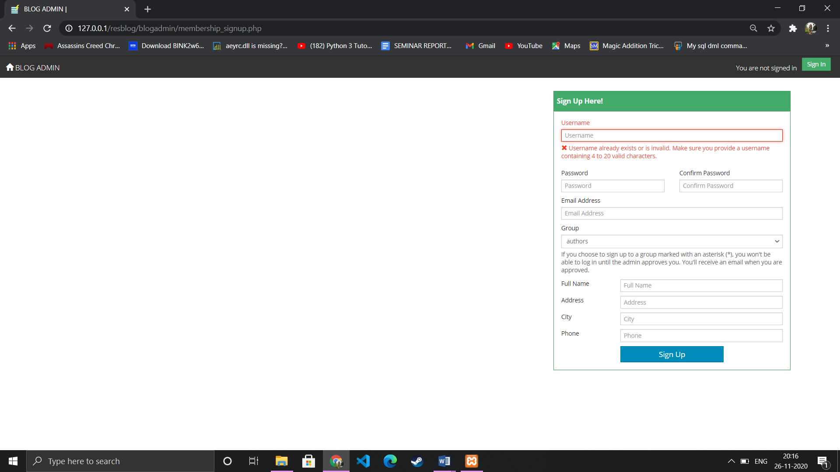

**Login page**

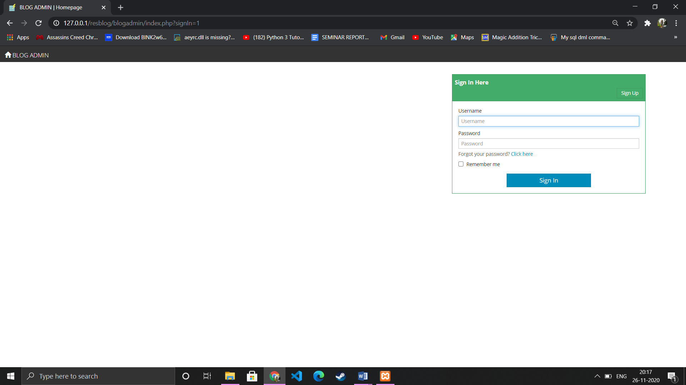

**Admin dashboard**

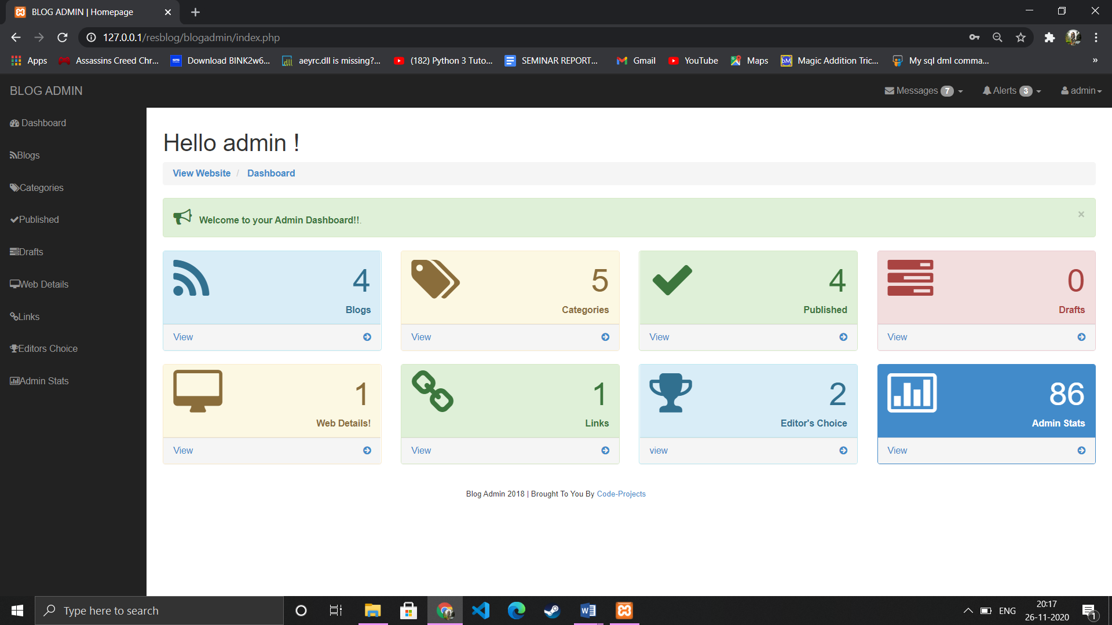

**List of blogs**

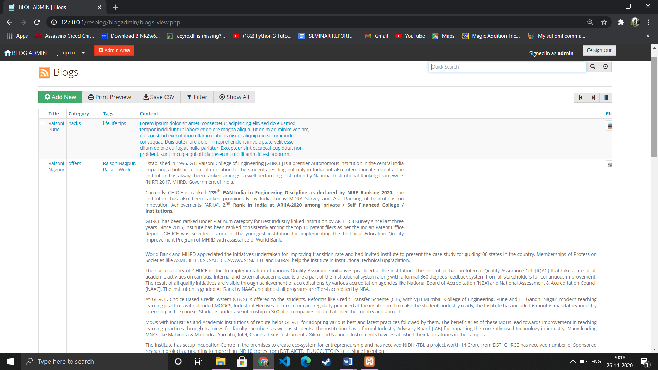

**Blog edit section**

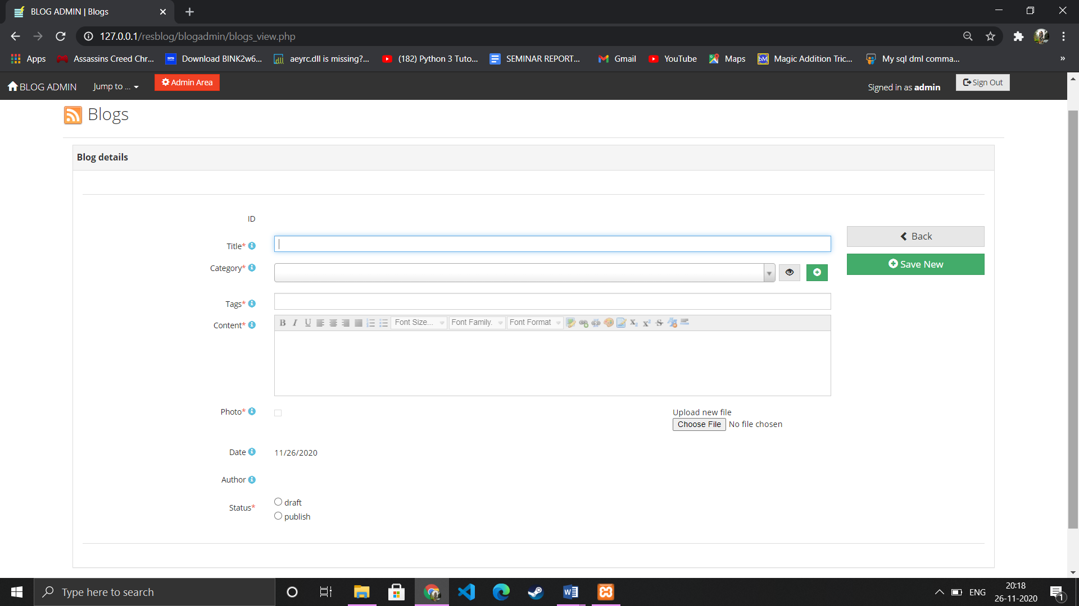

[Blog categories](http://127.0.0.1/resblog/blogadmin/blog_categories_view.php)

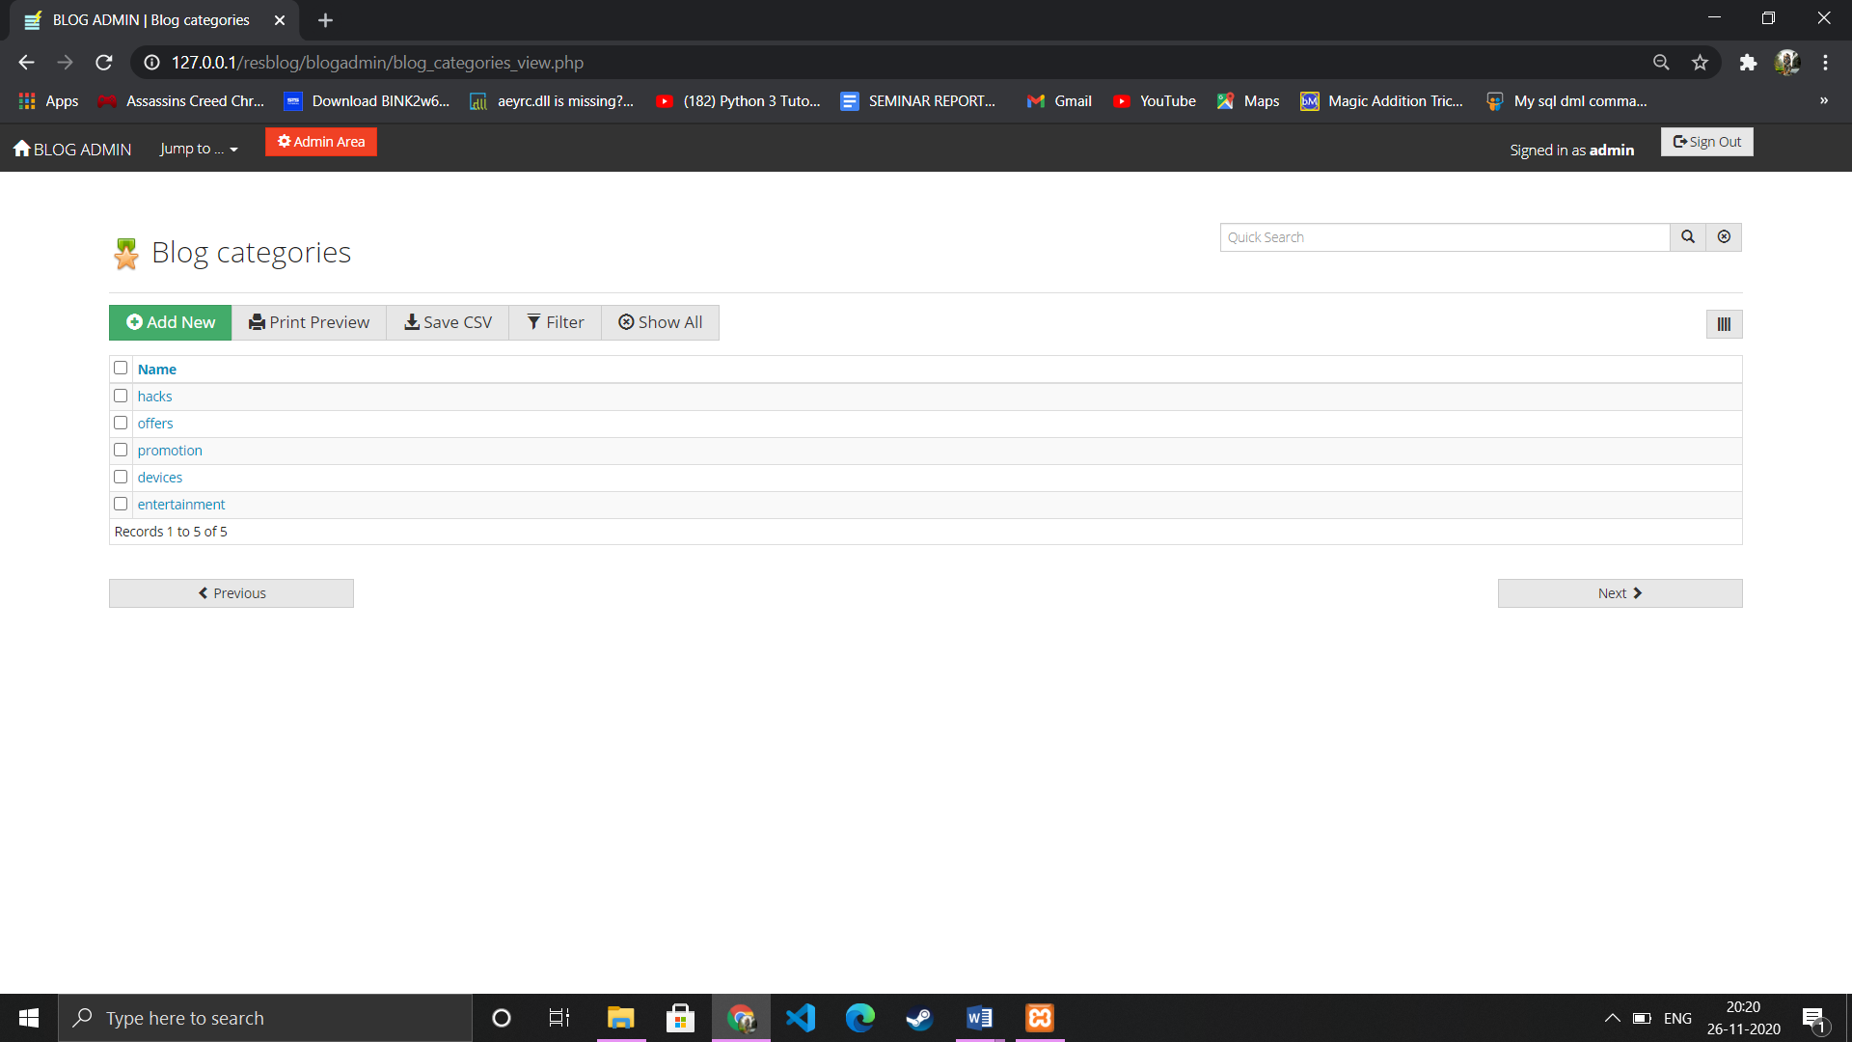

Add category

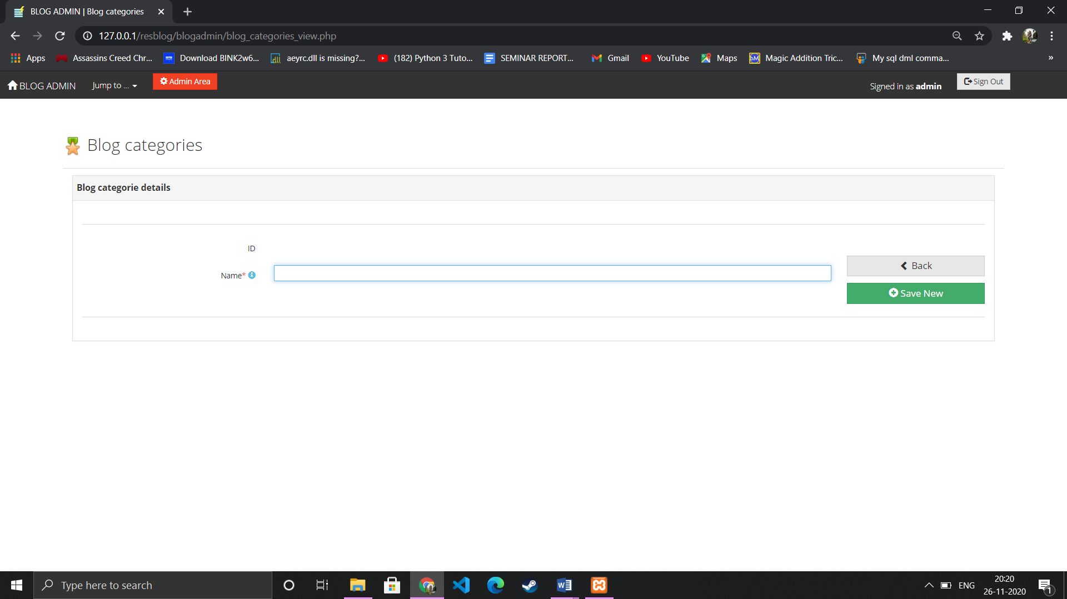

Published blogs

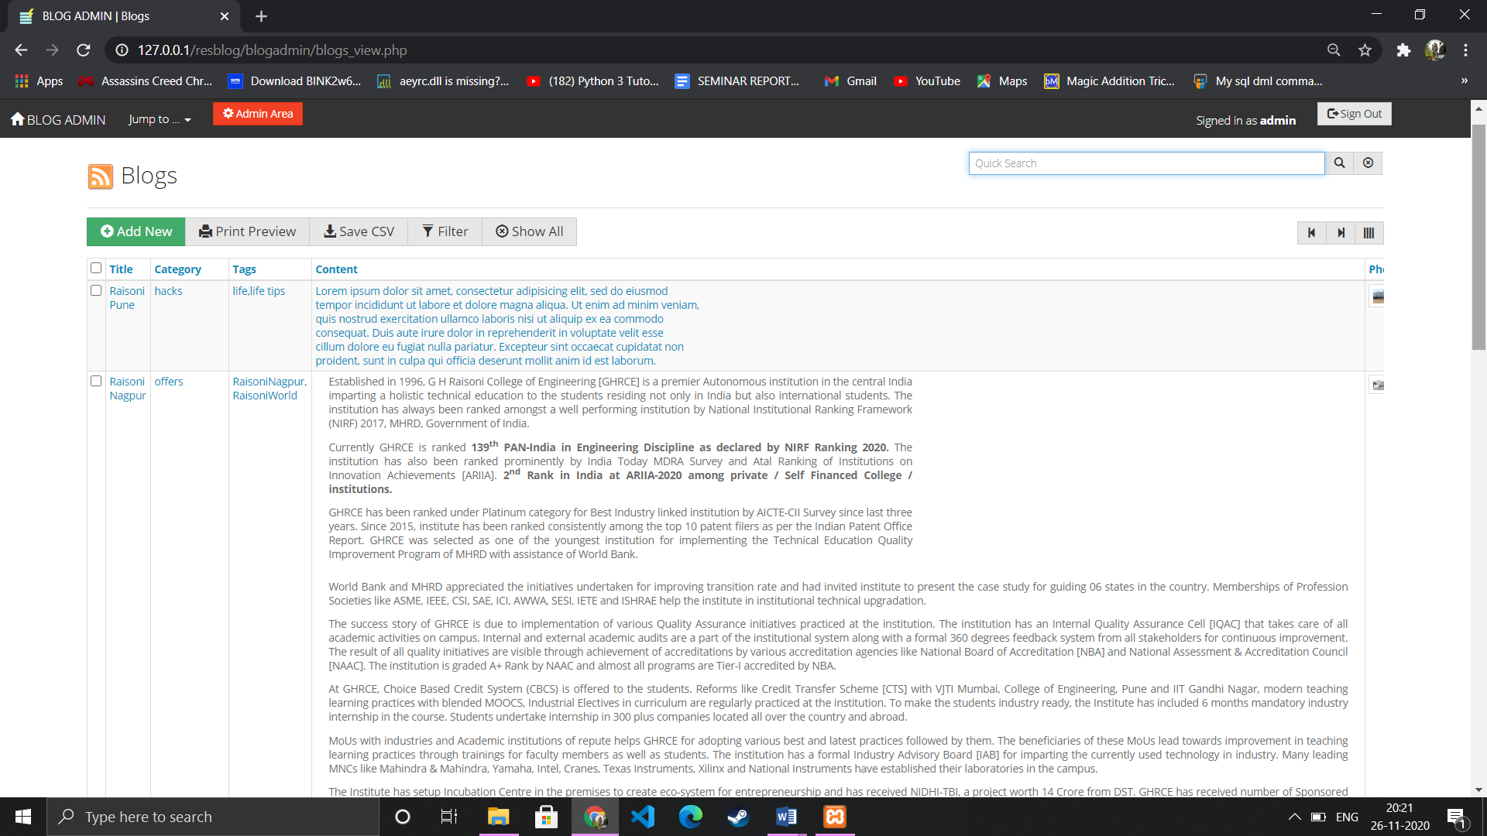

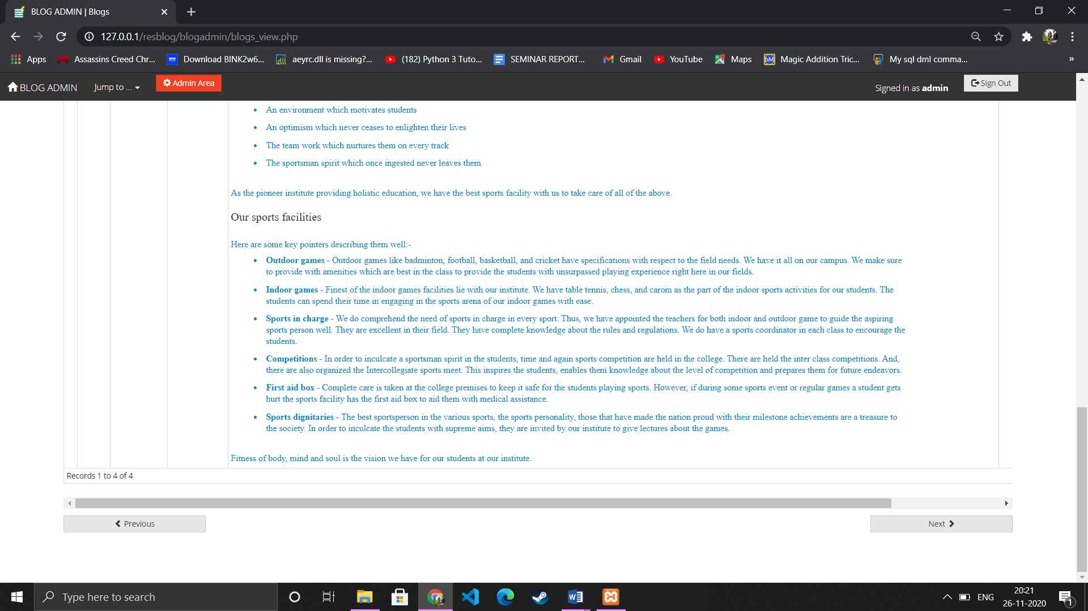

Web details

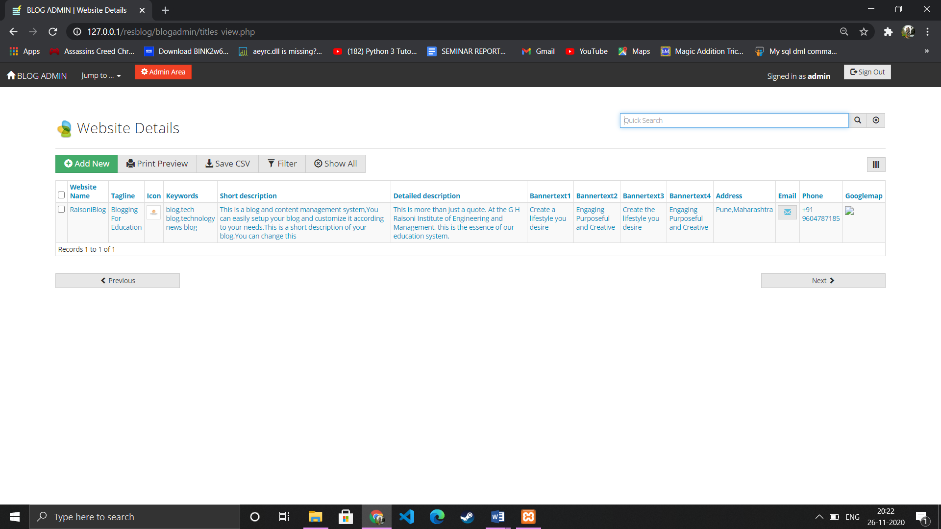

Links section

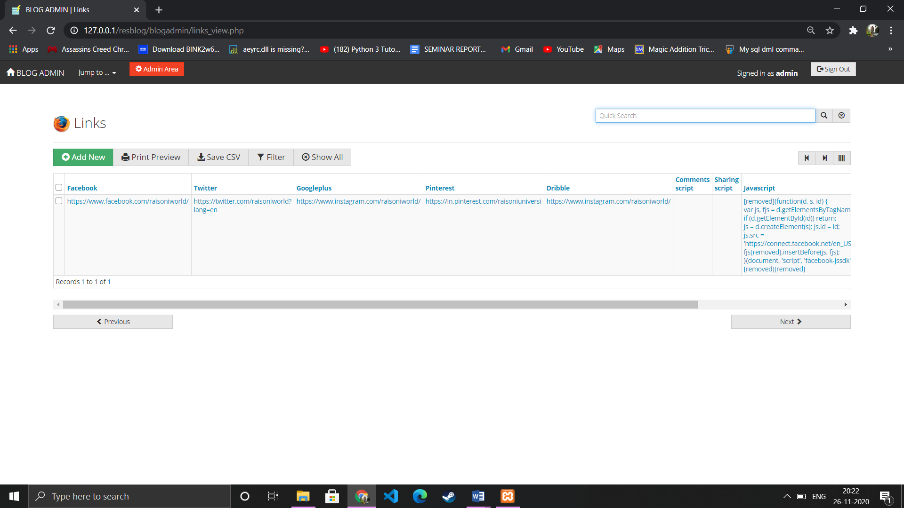

Editor’s choice

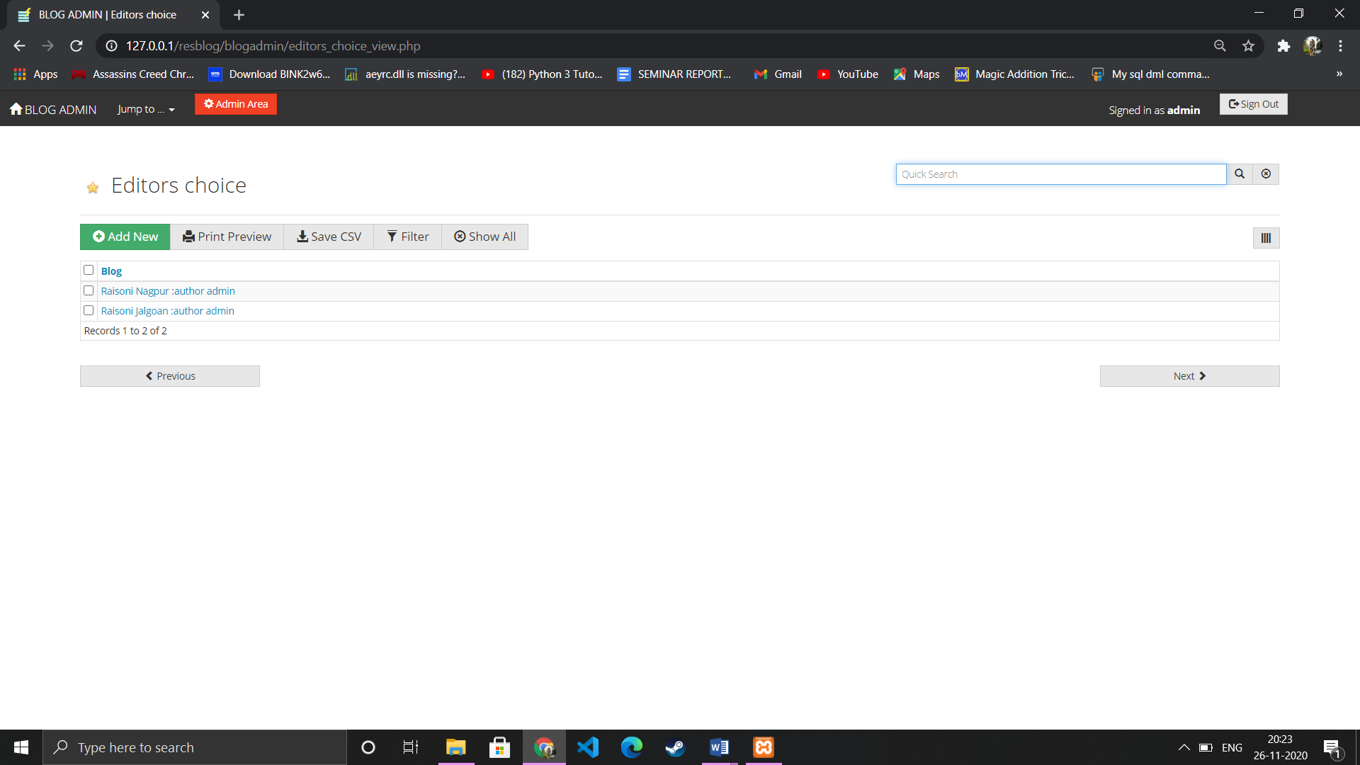

Admin log (activity status panel)

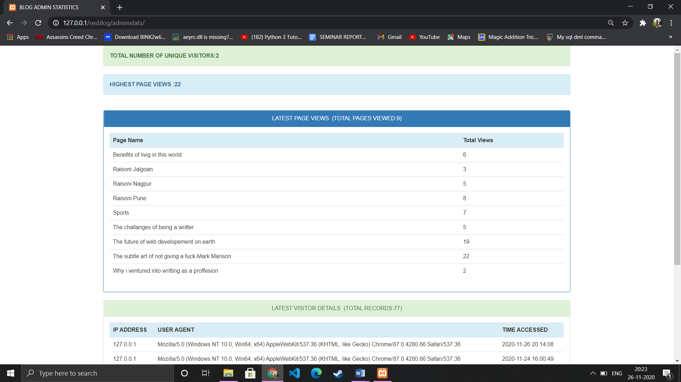

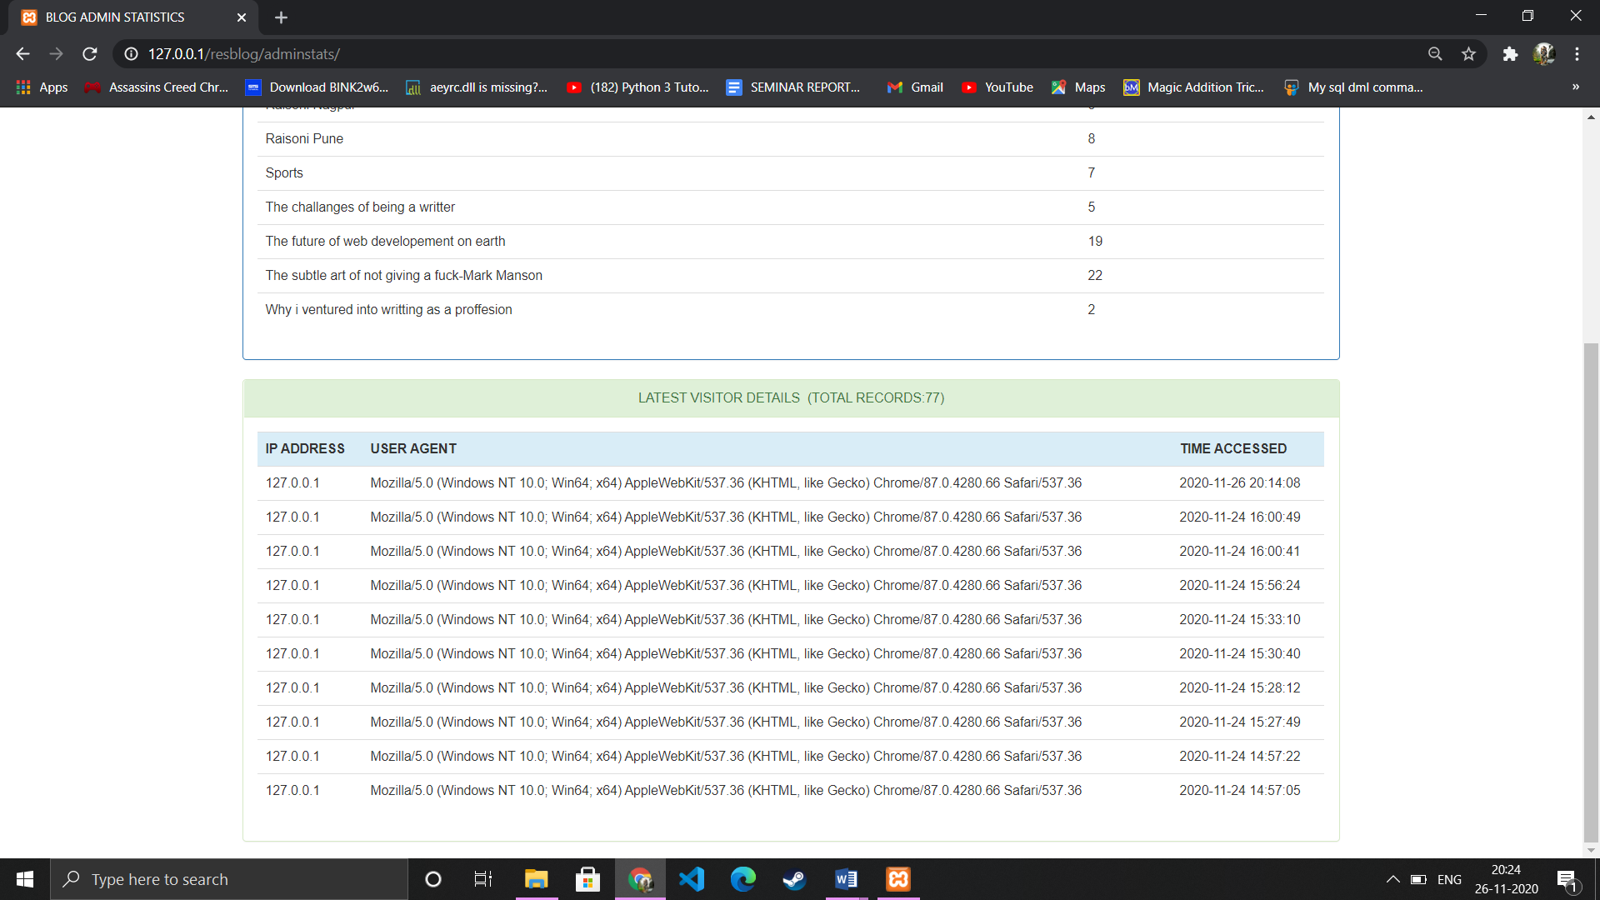

Admin management area

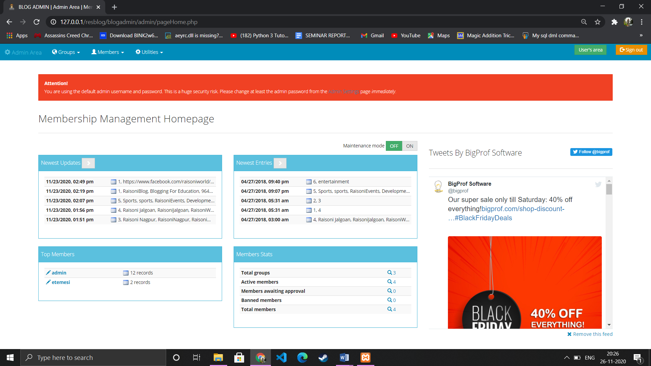

Manage members

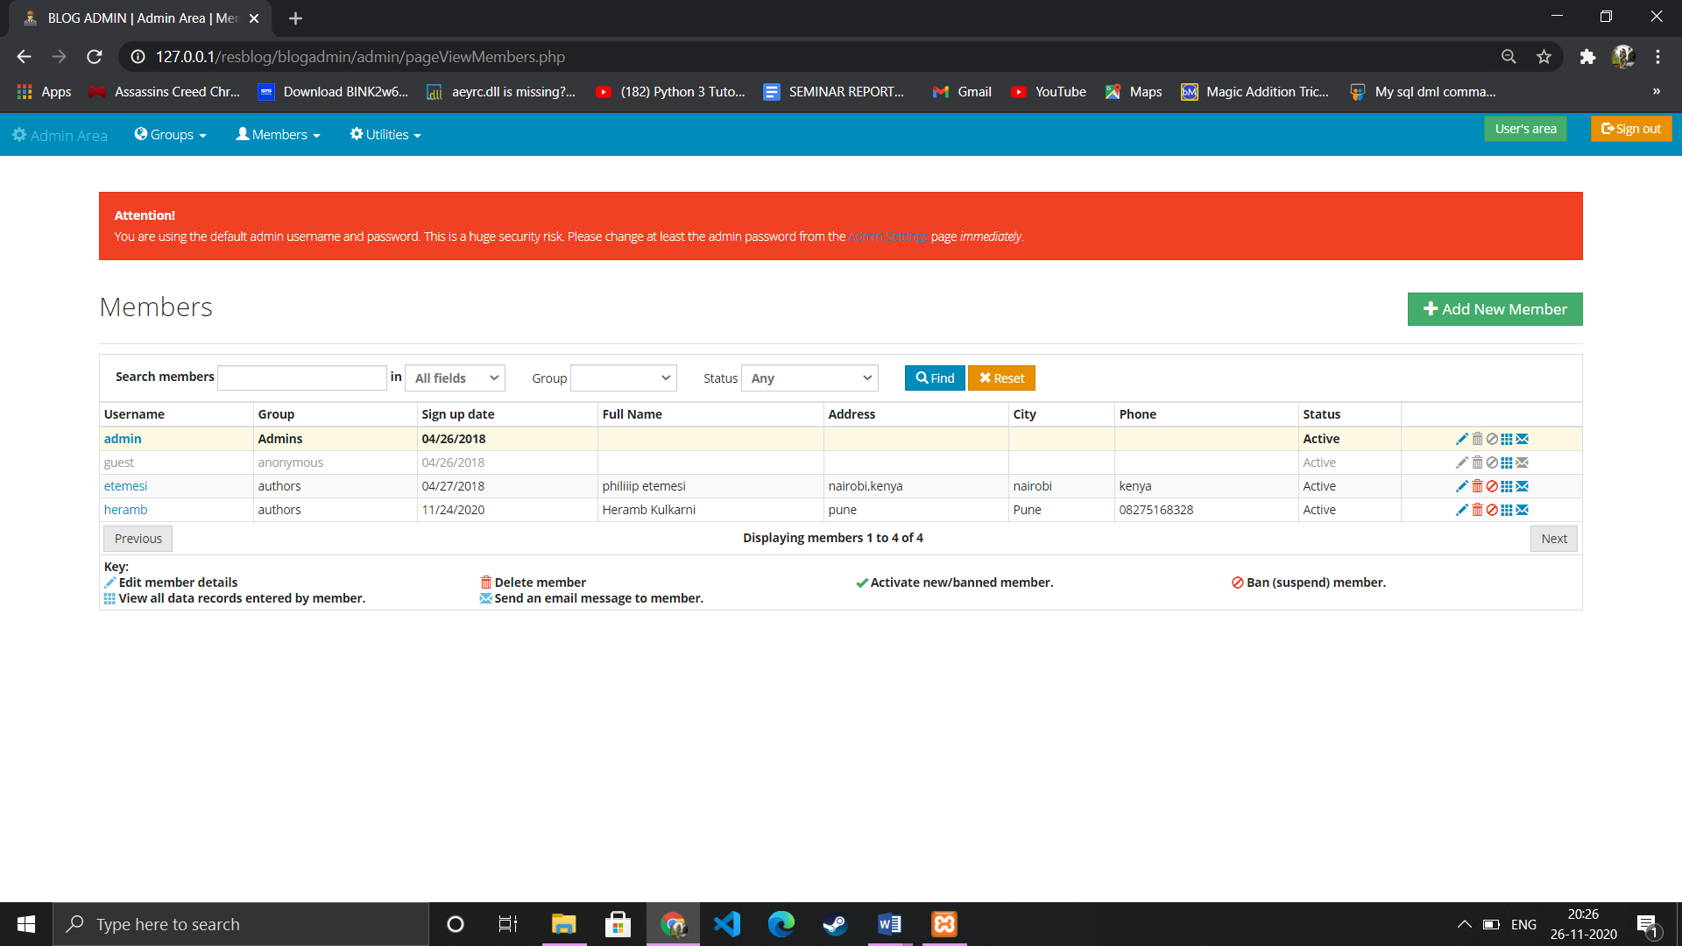

All groups

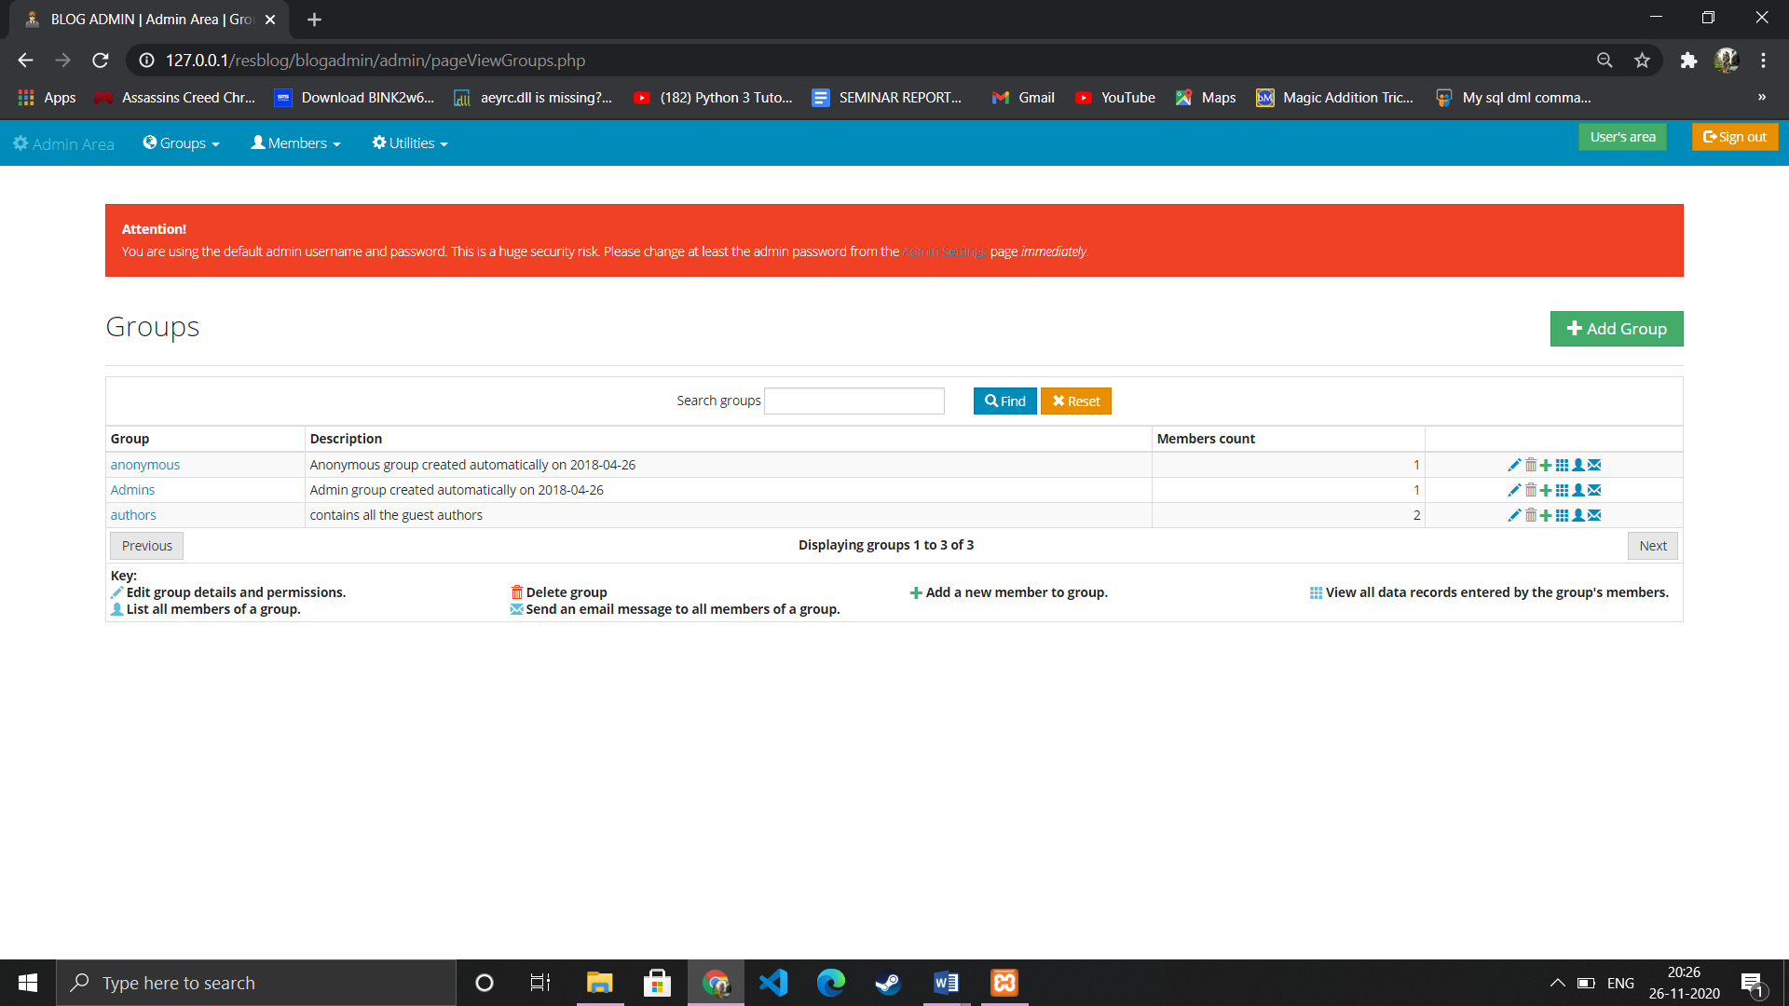

Admin settings

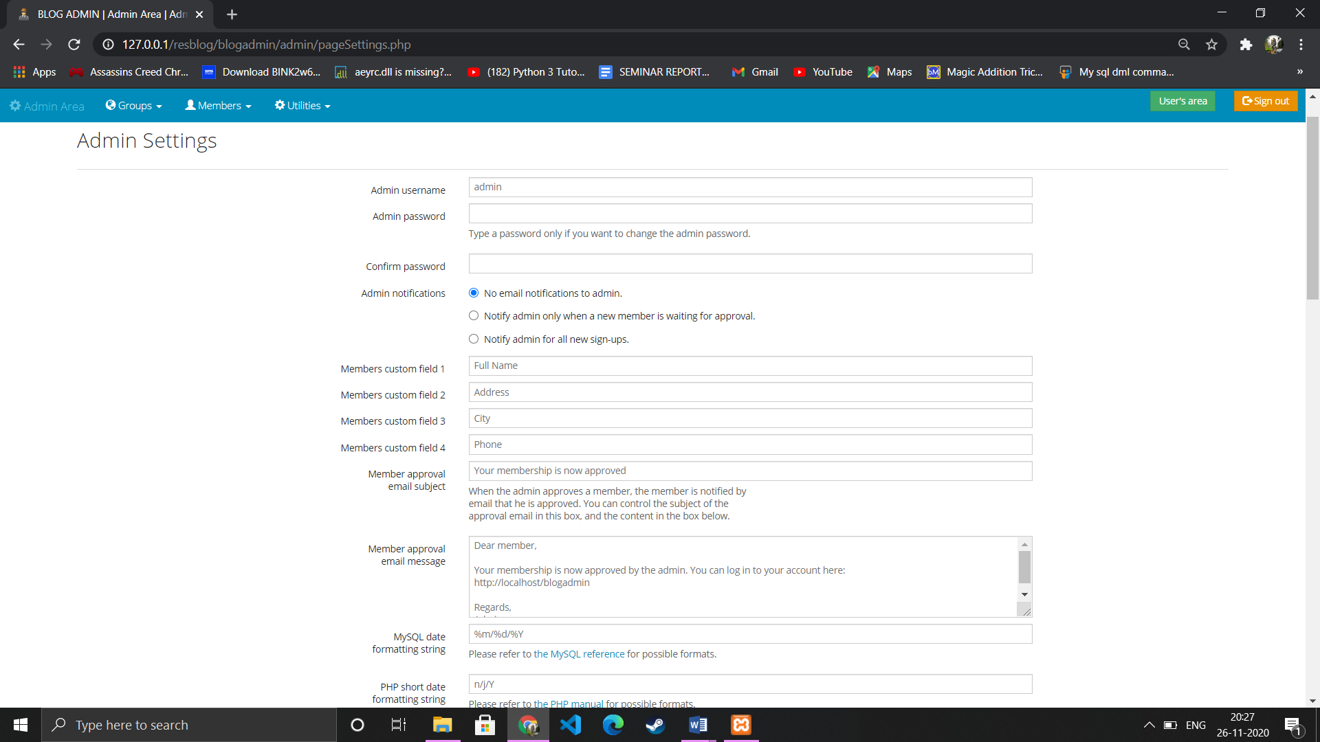

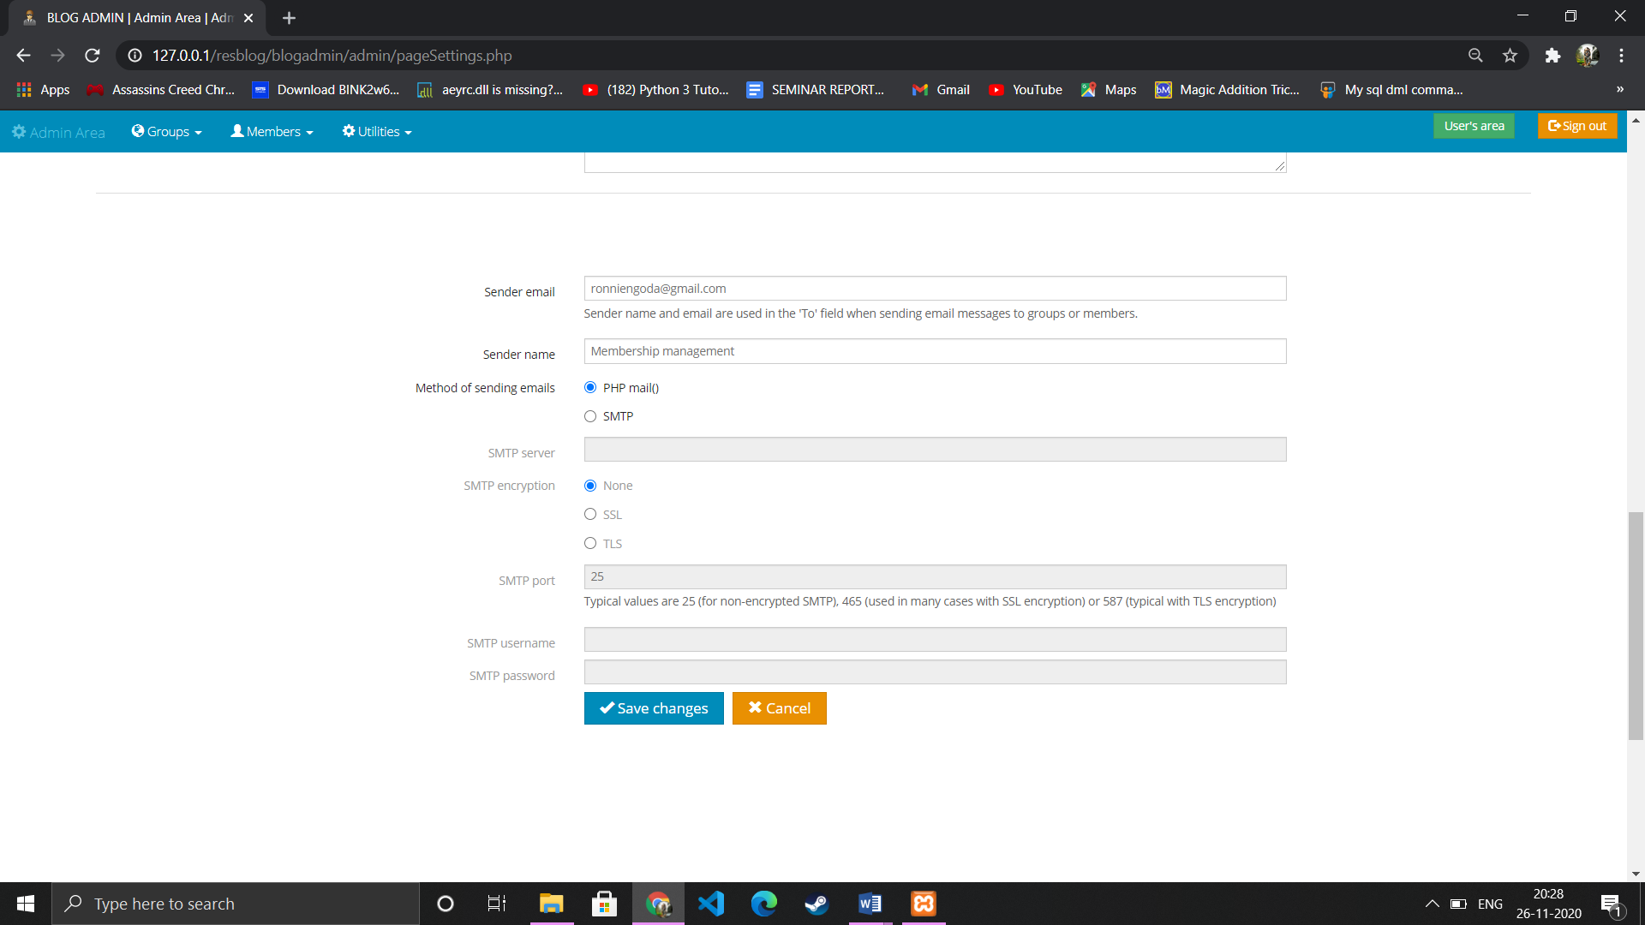

Database backup

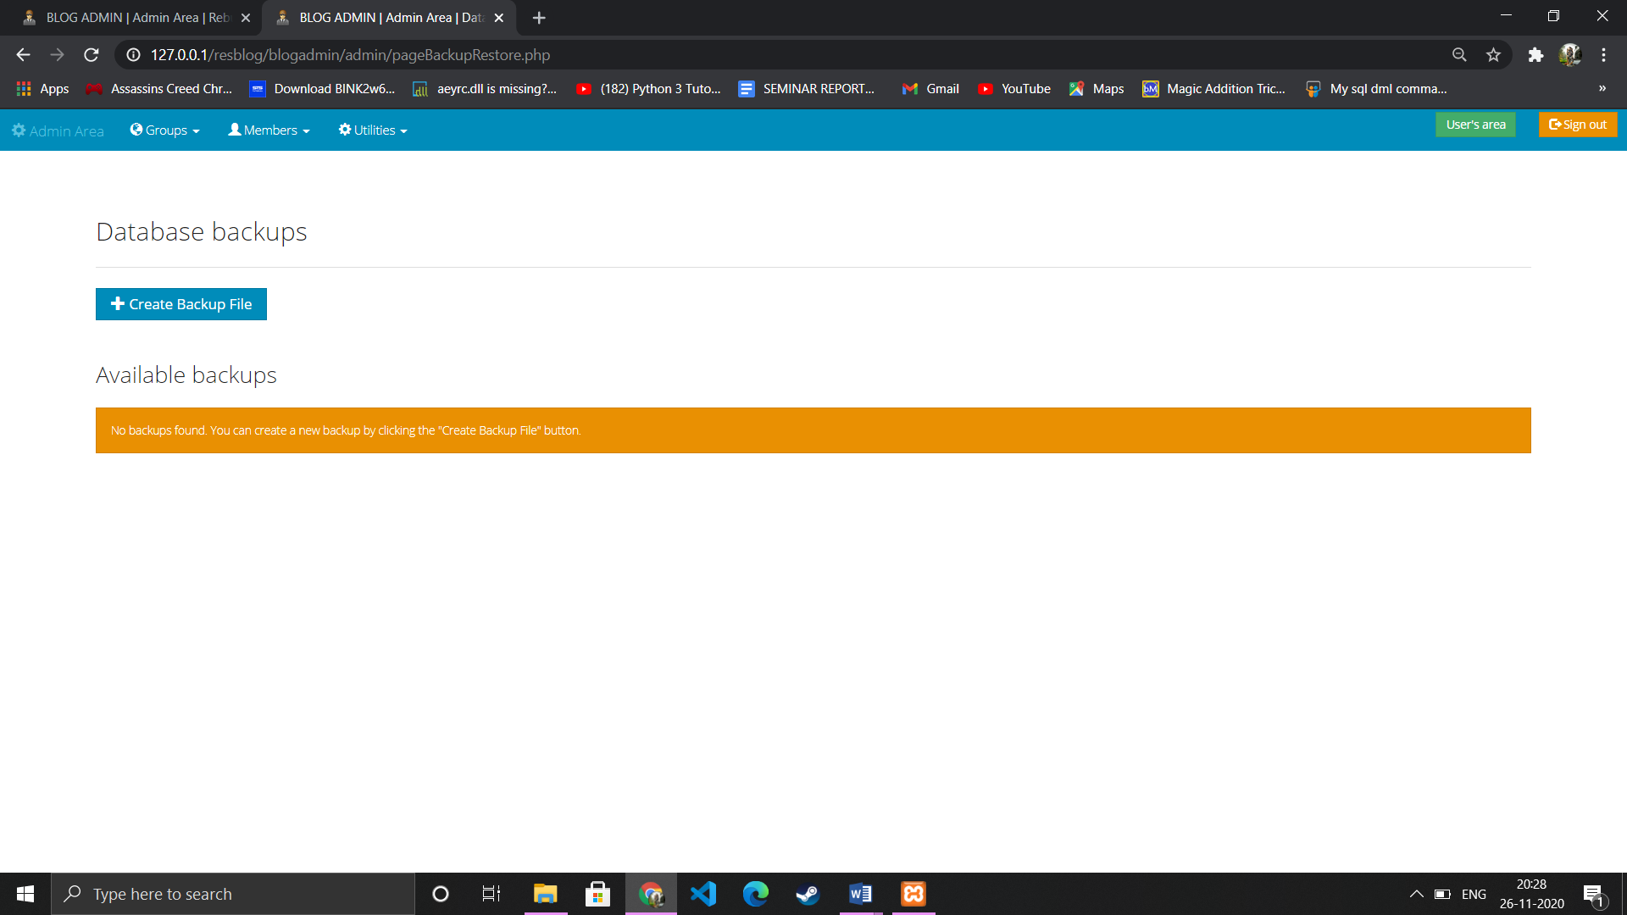

Message system to all users

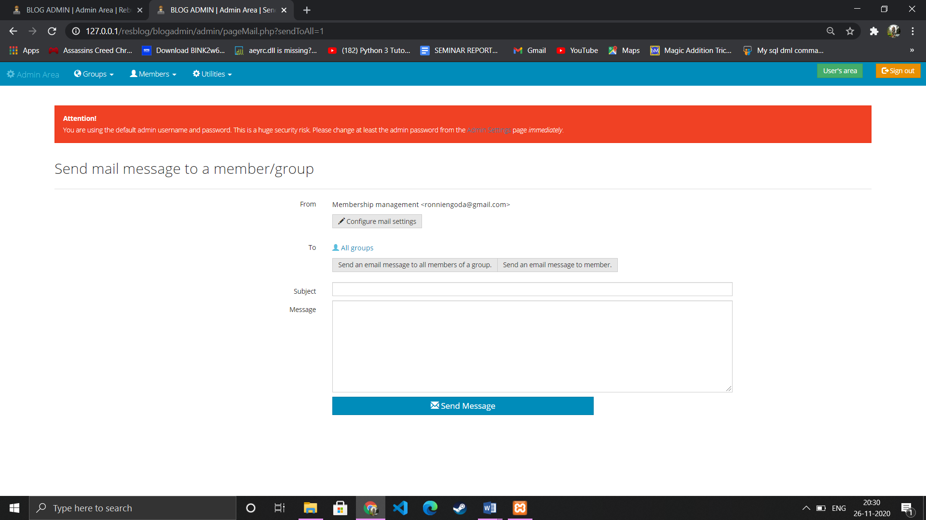

File import section

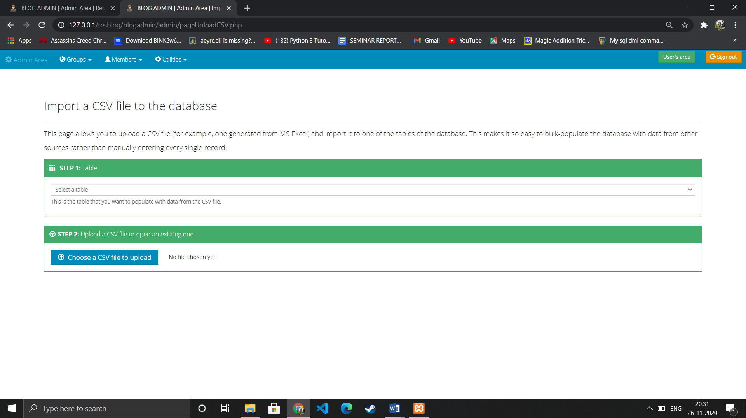

Rebiult fields

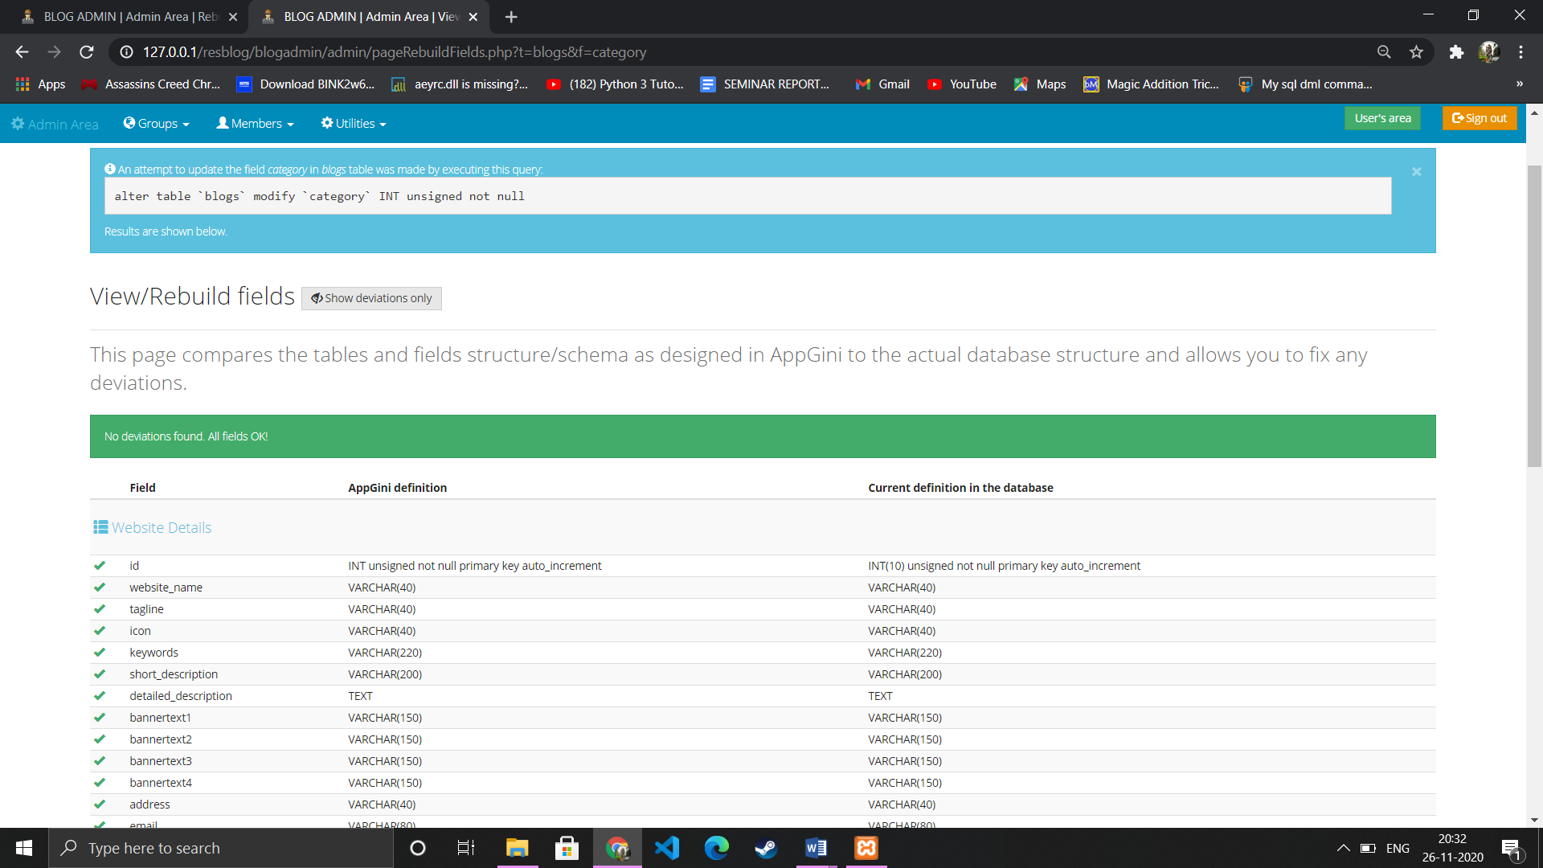

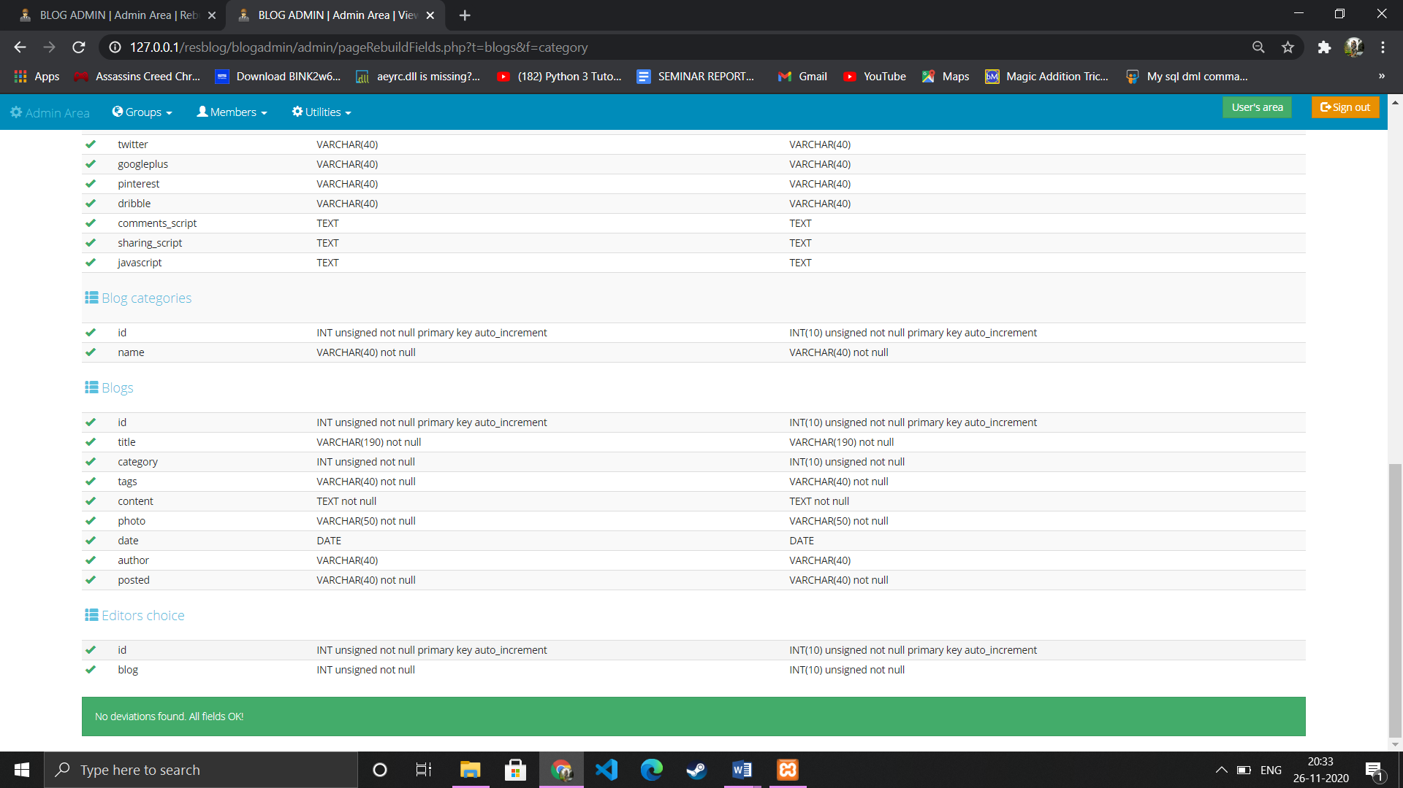

**Chapter 11**

**Future Scope**

This is the initila stage of bloging site. The site is dynamic so we can add different modules to our blog such as seprate section where useres can talk.

We can add two step verification for better security features.

Can make site more responsive so that, site can be operatable on low end devices.

Can built responsive app only for admin area to add, update and manage blog.

We can add printer in future.

We will host platform on online servers to make it accessible worldwide.

Create the master and slave database structure to reduce the overall of the database quries.

**Chapter 12**

**Conclusion**

Teachers are using blogs to provide up-to-date information and commentary on their subject areas, as well as posting questions and assignments and linking to relevant news stories and websites.

Ontology has been introduced to utilize semantic relations, enhanced by inference. Blog entries are mapped to the ontology using language processing. Search results are organized by introducing semantic aggregation. Blog entries are enriched by metadata and an annotation mechanism has also been developed. The framework has been tested and evaluated by implementing a system for the Institute of Technology domain ontology at VFU. Experiments have shown quite good results. Single sample ontology is created for demonstration.

**Chapter 13**

**References**

We have studying about PHP. MYSQL, etc. we have used Apache server and MySQL to store the data in database.

In making of report we got a lot of help from websites

Also we thank our mentor prof. Sonali Sonavane ma’am for guiding us.

* <https://www.youtube.com/watch?v=fPYOhQn95fw&list=PL3pyLl-dgiqD0eKYJ-XSxrHaRh-zsA2tP>
* <https://www.w3schools.com/>
* <https://stackoverflow.com/>
* <https://github.com/>